



**Solid Aerosol Fire Extinguishing System**

**Design, Installation, Operation, and Maintenance Manual**

**VERSION 1.0**

**November, 2024**

**Hankook Miboo Corporation**

**82, Amnam Gongwon-ro, Seo-gu, Busan, Republic of Korea**

|  |  |  |  |  |  |  |
| --- | --- | --- | --- | --- | --- | --- |
| **Table of Contents** | | | | | | **Page** |
|  |  |  |  |  |  |  |
| **1.0 Overview** | | | | | | **4** |
| **2.0 Product Introduction** | | | | | | **6** |
| **3.0 Description of the Fire Extinguishing System** | | | | | | **8** |
| 3.1 General | | | | | | 8 |
| 3.2 Extinguishing Agents | | | | | | 9 |
| 3.3 System configuration and control | | | | | | 12 |
| 3.3.1 FIREWALL Aerosol Generator | | | | | |  |
| 3.3.2 Electrical Operation | | | | | |  |
| 3.3.3 Control Panel and Accessories | | | | | |  |
| **4.0 System Design and Limitations** | | | | | | **16** |
| 4.1 General | | | | | | 16 |
| 4.2 Application | | | | | | 16 |
| 4.2.1 Calculate Aerosol Total Mass | | | | | |  |
| 4.2.2 Other facility/system considerations | | | | | |  |
| 4.2.3 Placing a Solid Aerosol Generator in a Protected Area | | | | | |  |
| 4.2.4 Generator installation instructions | | | | | |  |
| **5.0 Fire Extinguishing System Installation** | | | | | | **24** |
| 5.1 General | | | | | | 24 |
| 5.2 Installing the FIREWALL Solid Solid Aerosol Fire Extinguishing System | | | | | | 24 |
| 5.2.1 Installing the FIREWALL Solid State Aerosol Generator | | | | | |  |
| 5.2.1 Installing the Control Panel | | | | | |  |
| 5.2.1 Installing a Manual Control Box | | | | | |  |
| 5.3 Post-installation checks | | | | | | 27 |
| **6.0 Operations** | | | | | | **28** |
| 6.1 General | | | | | | 28 |
| 6.2 Operating Procedures | | | | | | 28 |
| 6.2.1 Manual operation | | | | | |  |
| 6.2.2 Remote Manual Operation | | | | | |  |
| 6.3 Post-Fire Procedures | | | | | | 30 |
| 6.4 Post-Fire Maintenance | | | | | | 30 |
| **7.0 Maintenance** | | | | | | **33** |
| 7.1 General | | | | | | 33 |
| 7.2 Checking for ice | | | | | | 33 |
| 7.3 Inspection Procedures | | | | | | 33 |
| 7.3.1 Troubleshoot | | | | | |  |
| 7.3.2 Weekly maintenance | | | | | |  |
| 7.3.3 Annual maintenance | | | | | |  |
| 7.3.4 Service, Replacement Cycle, and Removal | | | | | |  |
| **8.0 System Components** | | | | | | **36** |
| **9.0 Warranty** | | | | | | **41** |
| **Appendix - I Safety/Publishing Information** | | | | | | **42** |
| **Appendix - II MSDS** | | | | | | **49** |
| **Appendix - III Toxicity Test Results** | | | | | | **79** |
| **Appendix - IV Gas Sample Extraction Data** | | | | | | **96** |

**1.0 Overview**

This manual is intended for users who design, install, and maintain Hankook Miboo FIREWALL solid aerosol fire suppression systems. This manual contains design, installation, operation, and maintenance information for these fire extinguishing systems.

**Important notes**

Hankook Miboo is not responsible for the application of systems other than those mentioned in this manual, and the technical data in this manual is for informational purposes only. The U.S. Embassy in Korea recognizes that the contents of this document may not be complete and will be updated from time to time as changes occur. In addition, Hankook Miboo is not accountable for the use of the materials and information contained herein for any other purpose.

Hankook Miboo FIREWALL solid aerosol fire suppression systems shall be designed, installed, tested, maintained, and inspected by personnel qualified and trained in accordance with the following

* Aerosol regulations such as MSC1/Circ.1270, FSS Code, SOLAS, etc.
* Please refer to all instructions, limitations, etc. contained in this documentation, and be sure to contact Hankook Miboo at the contact information below if you have any questions.
* Storage, handling and transportation must be carried out by our employees (or separately trained workers) who are qualified and trained in accordance with IMO requirements.

If you have any questions about the information provided in this documentation, please contact Hankook Miboo using the information below;

Hankook Miboo Corporation

82, Amnam Gongwon-ro, Seo-gu, Busan, South Korea

Homepage: www.hankukmiboo.co.kr / Email: fire@miboo.co.kr

Tel: +82 (0) 51-263-3621 / Fax: +82 (0) 51-263-3734

**2.0 Product Introduction**

The Hankook Miboo FIREWALL solid aerosol fire extinguishing system is designed for all release coverage of each protective area in accordance with design standards. Application, design standards, and limitations are contained in this manual. In all situations not specifically covered in this manual, the application and installation of the fire extinguishing system must also be in accordance with the applicable standards. All installations must meet the requirements of the applicable regulations mentioned above.

FIREWALL solid aerosol fire extinguishing systems produce and deliver highly effective and technologically advanced fire extinguishing agents with unique operating and flow characteristics. Because these systems are designed and installed in a different manner than other fire extinguishing systems with which designers are familiar, designers must thoroughly understand and incorporate the design criteria contained in this manual into their designs in order to properly apply the design information and parameters. There are a number of limitations that must be observed when entering parameters to obtain accurate results.

FIREWALL solid aerosol fire extinguishing systems for ships consist of environmentally safe fire extinguishing agents, specially developed components and a control panel developed by the Hankook Miboo for reliable fire extinguishing agent dispensing. FIREWALL solid aerosol fire extinguishing systems reduce property damage and combustion products from fires to the lowest possible levels. They are electrically operated and extremely simple, and unlike other gas-based fire extinguishing systems, they do not require high-pressure vessels, nozzles, and distribution piping. FIREWALL solid aerosol fire extinguishing systems offer significant weight and space savings. Solid aerosol generators are placed evenly and strategically throughout the protective area and are designed to release within 120 seconds.

The fire extinguishing agent released by the FIREWALL solid aerosol generator is primarily a potassium-based aerosol with a particle size of 2 microns or less. This high-aerosol has the flow and properties of a gas after dispensing and has been found to be non-toxic to humans for short-term exposure at recommended design concentrations.

**3.0 Description of the Extinguishing System**

**3.1 General**

Hankoo Miboo FIREWALL solid aerosol fire extinguishing systems are used to extinguish fires of specific fire hazardous materials or equipment located in enclosed protected areas (spaces) with non-conductive extinguishing agents, low weight and footprint requirements relative to extinguishing capacity. The extinguishing agent is an ultra-fine aerosol that remains in suspension for a long period of time (up to 1 hour), providing excellent protection against re-ignition, as well as minimizing cleanup of the protected area after extinguishing the fire, as the residue of the extinguishing agent is low compared to other extinguishing agents. FIREWALL solid aerosol fire extinguishing systems can be used in machinery rooms and electrified spaces on ships, and can only be released manually in areas where occupants may be present, with a 30 second delay before release. It is intended for the protection of the vessel and is applicable in the following areas

* Ship Engine Room
* Pump Room
* Compressor room
* Control Room
* Battery Room (ESS)
* Areas requiring fire extinguishing equipment, such as other mechanical and electrical equipment operation (enclosed) areas.

FIREWALL solid aerosol fire extinguishing systems can extinguish the following classes of fires

* Class A - General fire (combustible solids)
* Class B - Flammable liquids
* Class C - Electrical/electronic equipment related to A or B

For substances or hazardous materials outside the scope described above, the suitability of the solid aerosol fire extinguishing system, required design concentrations, and human health effects must be discussed with HANKOOK MIBOO prior to design and application.

The FIREWALL Solid Solid Erosol Fire Extinguishing System **is not suitable** for areas where the following materials are present or handled. Please keep this in mind when designing.

* Class A materials that burn with deep burning characteristics (textiles, wood, etc.)
* Electrical equipment or facilities operating at 40,000 volts or higher
* Metal hydrides, exothermic materials, and chemicals that can ignite without air
* Metal powders (magnesium, titanium, etc.)

**3.2 Extinguishing Agents**

When a FIREWALL solid aerosol fire extinguishing system from Hankook Miboo, Korea operates, the solid aerosol generator produces ultra-fine potassium salts and a secondary inert gas. Potassium salts have long been recognized as one of the most effective extinguishing agents. Their halon-like combination of chemical and physical action extinguishes fires without negatively impacting the environment. In addition, the aerosol's ultra-fine particle size of 2 microns or less dramatically increases the surface area interaction between the extinguishing agent and the fire, resulting in rapid fire suppression. The potassium-based FIREWALL solid aerosol has already proven to be a highly effective alternative to other gas-based fire extinguishing systems in numerous tests and is installed and operated as a fire extinguishing system in many industries.

Unlike other gaseous fire extinguishing agents (CO2, Halon, etc.), FIREWALL solid aerosols do not decompose in the presence of fire and will not be extinguished or degraded by lack of oxygen. Solid aerosol fire extinguishing agents are MED approved as an alternative extinguishing device to IMO's FIXED GAS FIRE EXTINGUISHING SYSTEM. Solid aerosols are considered harmless to humans when used at typical concentration standard required to extinguish most fires, but due to their high opacity after action, certain safety restrictions must be observed during application and handling. Exposure to aerosols should be limited as much as possible and unnecessary exposure to particulates should be avoided. Exposure to aerosols is generally of less concern than exposure to decomposition products from fires.

Toxicity: In terms of human health hazards, the product has been tested for oral, dermal, and eye toxicity and has been found to be non-hazardous for accidental exposure. Exposure of less than 5 minutes is generally considered safe. Although aerosol components are considered non-toxic at normal concentration levels, they may cause short-term discomfort when combined with airborne ultrafine particles, so unnecessary exposure should be avoided. However, evacuation after activation may be restricted due to increased atmospheric opacity caused by ultrafine particles. Therefore, an automatic time delay of 30 seconds should be applied before activation of the FIREWALL solid aerosol generator to allow occupants to exit before the extinguishing agent is released, and manual activation should be made only after verification that the protected area is clear of occupants. For toxicity, refer to **Appendix-III Toxicity Test Results and Appendix-IV Gas Sampling** Data.

Corrosivity: Various tests have shown that FIREWALL solid aerosol is non-corrosive and non-hazardous to a variety of materials, including structural metals, plastics, and electrical components. In all of the above cases, FIREWALL solid aerosol fire extinguishing systems have been shown to have no detrimental effect on the operation and function of the equipment after extinguishing. If equipment or components are not thoroughly cleaned after aerosol release, some surface discoloration may occur, but this is a non-progressive phenomenon that does not affect functionality.

Cleanliness: Once the FIREWALL solids aerosol is sprayed, it remains in suspension for an extended period of time. Particulate extinguishing agents in aerosols remain in the extinguishing area for as long as it takes to extinguish, and can then be exhausted by ventilation fans or air circulation. Small amounts of extinguishing agent that settle on other structures or equipment, such as floors or equipment, can be swept or wiped up (e.g., with a vacuum cleaner). The particulates settled are trace amounts and are much less than the amount of particulates produced by the breakdown products of the fire.

Other safety considerations: During aerosol operation, the aerosol particulates released into the protective zone are relatively "cold". However, the ambient temperature within a certain distance from the outlet of the generator when the aerosol is released is above 100 °C. However, this maximum temperature is only maintained during the last few seconds of the release, after which the temperature drops rapidly.

The KF-5000S model FIREWALL solid-state aerosol generator has a specified installation clearance distance. We recommend placing the aerosol generator to comply with this installation requirement. However, even if sufficient separation distance is not available, the installation can still be done in consultation with a specialist from KOMIBU if there are no occupants or objects with low melting/ignition points (100°C or less) in the vicinity. The outer housing of the FIREWALL solid-state aerosol generator should be handled with care until it has cooled naturally to ambient temperature. If the aerosol generator is installed to discharge directly onto a wall or protected equipment, agglomeration may occur, but this does not affect the extinguishing effect.

Storage: FIREWALL solid aerosol generators are sealed with an impermeable metal cover, stored at temperatures between -40°C and 55°C and at a maximum humidity of 95% RH. In addition, accelerated aging tests have confirmed and validated the ability to generate aerosolized solid fire extinguishing agents for more than 10 years. However, as this data cannot be based on all environmental factors in the area where the FIREWALL generator is installed, it may be necessary to verify the effective performance of the generator by sample testing if necessary.

<Table 3.2.1 Main ingredients of fire extinguishing agent

|  |  |  |  |
| --- | --- | --- | --- |
| Substance name | CAS number | Percentage (%) | Remarks |
| Potassium Nitrate | 7757-79-1 | 72 |  |
| Cyanuric acid | 108-80-5 | 18 |  |
| Araldite Resin  (Poly(Araldit Resin G2)) | 25068-38-6 | 4 |  |
| phenolic  resin (phnolic resin) | 9003-35-4 | 6 |  |

**3.3 System configuration and control**

The fire extinguishing system consists of an aerosol generator, a receiving control panel, a manual operation box and an alarm.

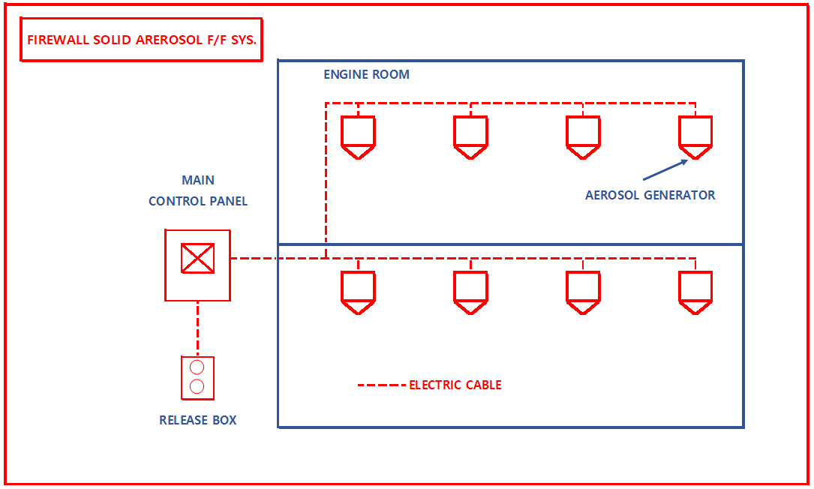

1. The circuits in the receiving control panel connecting the solid aerosol generators are redundant and extensively isolated rather than connected to the entire quantity of generators, and visual and audible alarms are provided to indicate a problem with any one of these circuits.
2. Essential wires within the protected area must be fire-resistant according to the standard IEC 60331 classification or equivalent.
3. The arrangement of the solid aerosol generator and the receiving control panel and manual operation box, which are essential for the operation of the system, shall be designed so that in the event of damage to one power supply wire or solid aerosol generator through mechanical damage, fire or explosion in the protective area, the amount of extinguishing agent required to achieve the test density will be distributed and released as uniformly as possible throughout the protective area, even if some damage occurs.
4. The operation and status of the solid aerosol fire extinguishing system shall be provided visually and audibly on the bridge and in areas where fire control equipment is concentrated.

3.3.1 FIREWALL Aerosol Generators: Each FIREWALL solid-state aerosol generator consists of an insulated steel housing containing the aerosol-forming compound, initiator, insulating media, and internal elements for oxidation and cooling of the aerosol stream prior to release from the device. The initiator utilizes a secure two-wire connector for electrical activation and a proprietary thermal detector for thermal activation. Each generator is sealed and utilizes an impermeable membrane to maintain the integrity of the generator internals, even in humid and hot environments.

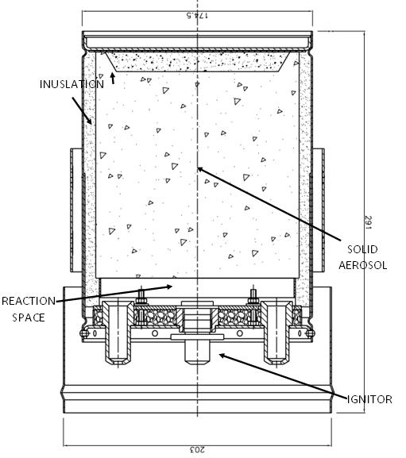

**Cross-sectional view of FIREWALL Solid Aerosol Generator KF-5000S**

<Main generator specifications

|  |  |  |  |  |  |
| --- | --- | --- | --- | --- | --- |
| MODEL | Fire Suppressant Dosage (g) | Diameter (mm) | Length (mm) | Product weight (Kg) | Remarks |
| KF-5000S | 5,000 | 203 | 291 | 13.2 | MED Cert. |

3.3.2 Electrical operation: The ignition mechanism of the FIREWALL solid aerosol generator consists of a two-wire connector for electrical operation. The two-wire connector and the ignition mechanism are safe and reliable devices. The electrical parameters of the ignition are as follows

* Resistance: 1.2 to 2.2 Ohm
* Ignition current: 0.3 A
* Control current: 0.05 A (within)
* Ignition voltage: DC24 V
* Ignition current minimum time: 5 ms
* Resistance after ignition: 2 KOhm

The rated operating voltage is 24 V DC.

3.3.3 Control panel and accessories: configured to be compatible with the aerosol generator in accordance with IMO requirements.

3.3.3.1 Fixing bracket: The steel bracket is used to mount the aerosol generator.

3.3.3.2 Hand Operated: If compatible with the control panel and permitted by authorities having jurisdiction, the FIREWALL solid aerosol fire extinguishing system can be operated using the hand operated buttons.

3.3.3.3 Timeout: A timeout of at least 30 seconds should be used in the following zones

Personnel can be stationed in a protected area to ensure that personnel in that protected area can evacuate prior to system activation. While the aerosol itself does not pose a significant health risk to occupants, occupants should leave the protected area before system activation to avoid potential issues related to itching or minor irritation from inhaling the ultrafine dust.

3.3.3.4 Horns/Alarms: Horns/Alarms alarms are compatible with the control panel and should be used with a time delay to provide an audio and visual warning to the occupants of the protected area that a system action is imminent and that the protected area should be evacuated.

**4.0 System Design and Limitations**

**4.1 General**

The system design is based on MSC.1/Circ. 1270 criteria and the manufacturer's design information and the requirements of the authority having jurisdiction.

**4.2 Applying the system**

To design and calculate a HANKOOK MIBOO FIREWALL solid aerosol fire extinguishing system, you must perform the following steps.

* Check how the zone is being used.
* Check the applicability of the applicable protection zone (see 3.1 General).
* Determine the design density.
* Check for hazardous containment and possible leaks.
* Determine the geometric dimensions (volume, area, height) of the hazardous area. (The volume of equipment within the hazardous area can be subtracted from the total volume).
* Make sure that there are no large structures or obstacles within the defense zone.
* Determine if additional extinguishing agents or generators are needed to compensate for leaks or obstructions.

4.2.1 Calculate the total mass of aerosol required to protect the hazardous material.

The required mass of aerosol for a certain volume is calculated according to the formula: :

**Formula: M = V x Q**

M: The total mass of aerosol required to protect the hazard.

V: The total volume (volume, cubic meters) of the protected area.

Q : What is the design density of FIREWALL solid aerosol generator KF-5000S (52g/M³)?

The following formula is used to calculate the quantity of aerosol needed for a fire extinguishing system:

**Formula: N = M/m**

N: The quantity of aerosol generators needed. (If the value of N is a decimal, it is rounded up to an integer.)

M: The total mass of aerosol required.

m: Mass of the individual aerosol generator, the FIREWALL Solid State Aerosol Generator KF-5000S has a fire extinguishing agent mass of 5,000 g/EA.

4.2.1.1 Emission Range: Each FIREWALL aerosol generator has an emission range of up to 5 meters radius and 10 meters height. Once the quantity of aerosol generators required to radiate the required aerosol mass has been determined, the area of each protective zone should be reviewed to ensure that the aerosol generators are as evenly spaced as possible. The radius and height are limits for either radius or height, not both.

4.2.1.2 Review of Excess Pressure ΔP: In general, few containment areas are completely enclosed, so excess pressure is not an issue at typical design concentrations. However, for completely "enclosed" containment areas (LP=0), it is recommended that the structure be reviewed and vents installed if deemed necessary.The rise pressure for a release at the required design density in a completely enclosed area is

* 2 Kpa at 52 g/m³ design density
* 3 Kpa at 75 g/m³ design density

If the structural evaluation of the protective area does not satisfy the above rising pressure value, it is recommended to install a louvered vent, the size of which should be minimal and the location should be at the top of the area away from the generator. No additional chemicals are required for the installation of the vent.

4.2.2 Other facility/system considerations

4.2.2.1 Significant obstructions/distribution of extinguishing agent: If the ratio of fixed equipment to the total volume is large or if the protective equipment is located in such a way as to impede the free flow and distribution of the aerosol throughout the hazardous area, it is recommended that a larger number of aerosol generators be used.This will allow for strategic placement of the aerosol generators and improve the distribution characteristics throughout the area. See Figure 4.2.3 Installation in the presence of significant obstructions.

4.2.2.2 Global Release Methods in Protected Areas Where People May Be Present (TOTAL FLOODING): When installing a global release installation in a normally unoccupied protected area where people may be present, a 30-second release time delay is required to allow for escape time before the system releases.

4.2.2.3 Shutdown of air ventilation and power supply: If a fire is detected prior to the release of the extinguishing agent, the ventilation system of the protected area must be shut down to ensure that the required application density is delivered and that the fire does not worsen due to excessive airflow. In addition, power must be shut off to the equipment to be protected.

4.2.3 Placement of Solid Aerosol Generators in Protected Areas

4.2.3.1 Typical placement of aerosol on solids in a protective zone: The generator has the following release characteristics within seconds of release

Aerosol Emission Characteristics

* Emission effective radius: up to 5 meters
* Emission effective distance: 2m to 10m
* Emission effective height: 10 meters
* Minimum height of emission: 2 meters

**<Figure 4.2.4.1 Low zone emission pattern>.**

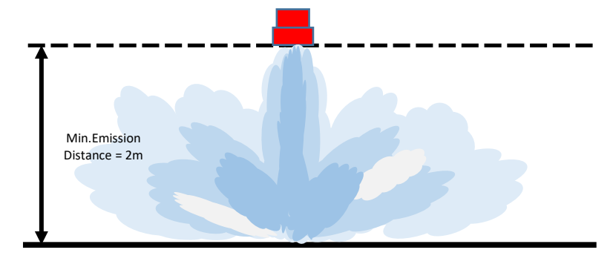

**<Figure 4.2.4.2 High zone emission pattern>.**

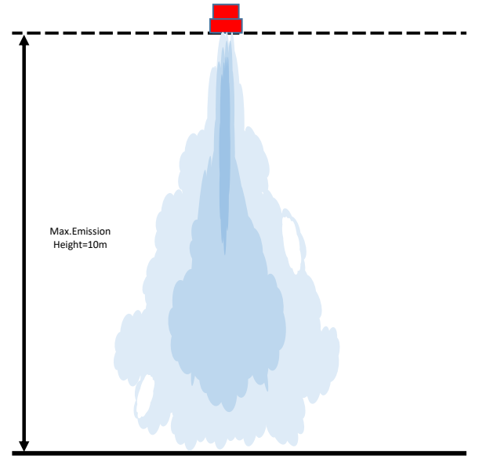

<Figure 4.2.4.1> A low-zone release fills the space as the aerosolized agent hits the floor, forming an aerosol plume.

<Figure 4.2.4.2> Emission in the high region forms an emission cloud up to about 8 meters with the emission energy and then fills the space by free diffusion.

4.2.3.2 Installation Criteria: Installation limits based on emission characteristics are as follows

* Installation height: minimum 2 meters to maximum 10 meters
* Maximum area COVERAGE of the generator: 7m x 7m
* Minimum distance between generator outlet and structure: 2 meters

4.2.3.3 Installation: The principle is to install the generator vertically and uniformly on the upper ceiling to reach the release density. Refer to <Figure 4.2.4.3>, this can make the fire extinguishing agent spread uniformly in the protective zone to form a rapid fire extinguishing density to achieve rapid fire extinguishing.

4.2.3.4 For small areas or where obstacles are high and numerous: installation can be made on walls, columns, etc. near the ceiling to reinforce the emission pattern; in this case, it can radiate downward with an angle of 10° to 30° to ensure the direction of emission into the unoccupied space; in this case, a larger number of aerosol generators can be installed to fill the partial lack of fire density, see <Figure 4.2.4.4>.

4.2.3.5 Installation in high areas: As mentioned in 4.2.4.1, the maximum installation height is limited to 10 m. Above this height, the aerosol generator must be placed on multiple levels to ensure global emission.If multiple generators are to be installed in the same area, they should be placed on different levels according to the height of the area, with each level complying with the installation height and maximum area coverage limits. This ensures complete and even distribution of the aerosol throughout the area. <Figure 4.2.4.5>.

4.2.3.6 Installation in low areas: As mentioned in 4.2.4.1, it is possible to emit horizontally if it is lower than 2 meters, in this case, the emission area must be observed, and the emission distance can be arranged within a range not exceeding 10 meters, see <Figure 4.2.4.6>.

For areas not mentioned in the above cases, please contact our design department and we will provide a solution for your installation.

4.2.4 Generator installation instructions

This guide is an example of an installation, and we recommend that you consult with a design expert at MIBU for guidance based on your installation environment.

**<Figure 4.2.4.3 Vertical installation of the generator>.**

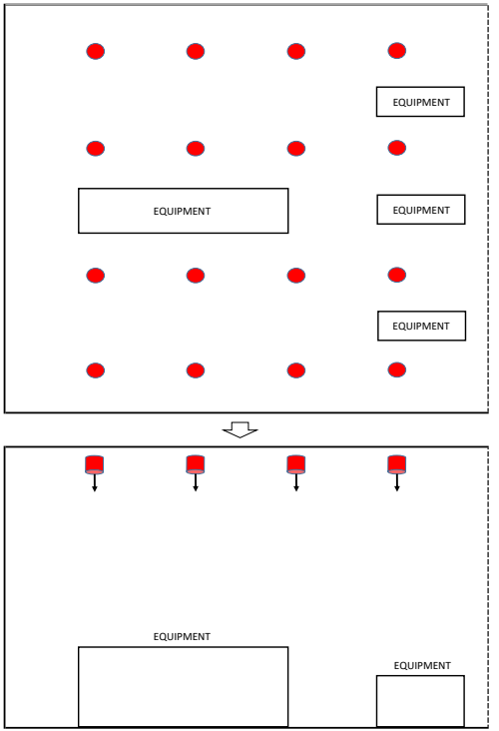

**<Figure 4.2.4.4 Area with Obstacles**

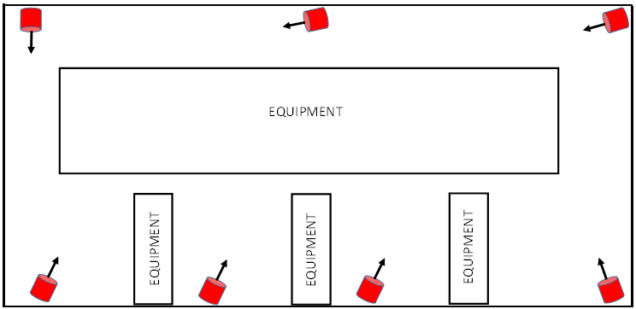

**<Figure 4.2.4.5 High Zone Installation**

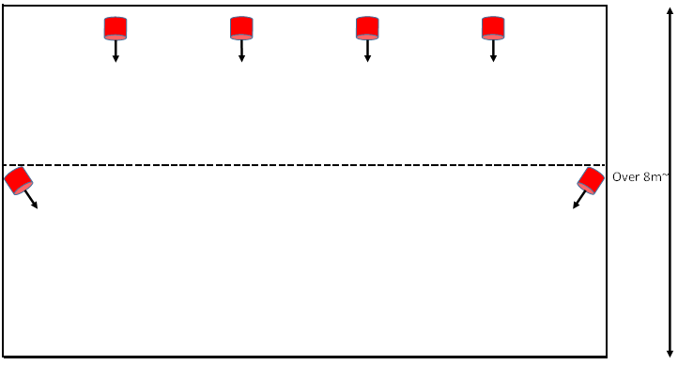

**<Figure 4.2.4.6 Low Zone Setup>.**

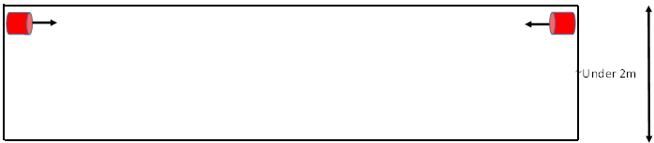

**5.0 Installation of the Fire Extinguishing System**

**5.1 General**

All HANKOOK MIBOO FIREWALL solid aerosol fire extinguishing systems shall be installed to facilitate proper operation, inspection, testing, and other necessary maintenance. The system components shall not be subjected to mechanical, chemical, or other damage that could affect the operation of the fire extinguishing system. The system component equipment must be installed in accordance with all applicable standards and the contents of each part of this manual.

**Warnings**

**The FIREWALL solid aerosol generator contains a flammable solid charge and must be handled, installed, and serviced only in accordance with the instructions contained in this section.Failure to follow these instructions may result in premature release and personal injury.**

**5.2 Installing the FIREWALL Solid State Aerosol Extinguishing System**

The FIREWALL solid aerosol fire extinguishing system must be installed within a protected area. To prevent accidental release, personal injury, or damage to property, the following installation instructions must be followed in the correct order, and it is recommended that hazards outside the scope of this manual be avoided during installation.

**Warnings**

**To prevent personal injury, disconnect power to all electrical connections before installing the generator.**

5.2.1 Installing the FIREWALL Solid State Aerosol Generator

1. Position the bracket for mounting the aerosol generator on a solid surface and secure it to a wall, ceiling, or other support in a location and manner that will securely fasten it to the wall, ceiling, or other support to prevent accidental damage or movement of the generator.
2. Ensure that the solid aerosol generator is optimally positioned and installed in a way that ensures flow and extinguishing efficiency when releasing the extinguishing agent.
3. After removing the packaging of the solid aerosol generator and performing a visual inspection to ensure that there are no cosmetic defects, if you find any tears or damage to the exterior, such as missing or damaged wires on the top, do not install and contact us immediately. Check the integrity of the ignition wire with an ohmmeter, if the reading is outside the range of 1.2~2.2 Ohm, please stop the installation.
4. Align the bracket with the side of the generator and the angle of the bracket, making sure that all bolts securing the bracket are securely in place, and then tighten the bolts securely.
5. Adjust the bracket swivel to position the generator so that it can discharge unobstructed when operating.Care should be taken to ensure that the generator does not discharge directly at close range from walls, ceilings, or vertical surfaces of equipment in the hazardous area.The generator should be positioned to promote circulating flow and mixing of aerosols from multiple generators.Aerosol generators should never be positioned to discharge directly toward each other.This can cause aerosol particles to agglomerate and reduce the extinguishing effectiveness of the aerosol.
6. Solid aerosol generators can be connected individually to the fire receiving and motion control panel or in series in a loop. The wires connected to each generator must be supplied with a constant current as follows

*The electrical specifications of the generator are as follows

* Resistance: 1.2 to 2.2 Ohm
* Ignition current: 0.3 A
* Control current: 0.05 A (within)
* Ignition voltage: DC24 V
* Ignition current minimum time: 5 ms
* Resistance after ignition: 2 KOhm
* Operating temperature range: -60 °C to 125 °C

1. After making sure the power is off, connect the wires to the ignition fitting on the top of the solid aerosol generator.

5.2.2 Installing the Control Panel

1. The control panel should be located in one of the following locations, preferably the same location as the control panel of the FIRE DETECTION SYSTEM, in an occupied area where the fire extinguishing system can be immediately checked and acted upon.

* WHEEL HOUSE
* engine control room
* fire control station
* ETC

1. We recommend installing it at a height of 1.5 meters to 2 meters where it is immediately visible and can be easily seen.

5.2.3 Installing a Manual Control Box

1. A manual control box is placed outside the main entrance and exit of a protective area where it can be operated while evacuating after detecting a hazard in the protective area.
2. If you have more than one main entrance, install it on each main entrance.
3. Install at a height of 0.8 meters to 1.5 meters for ease of operation.

**Warning**

**To prevent personal injury, disconnect all power before installing the solid aerosol generator. During installation, make sure that no body parts are positioned in front of the discharge port of the solid aerosol generator (to avoid malfunction).**

* 1. **Post-installation checks**

After installing the USMIT FIREWALL solid aerosol fire extinguishing system and connecting it to the supplied control panel, the following inspections and tests must be performed.

1. Verify that the generator is installed in the correct location according to the installation drawing.
2. Verify that the solid-state aerosol generator bracket is installed correctly and that all fasteners are secure.
3. Verify that all electrical connections are complete and test the electrical connections by checking the FAULT LAMP on the control panel.
4. Verify that all solid aerosol generators are positioned correctly, checking against the drawing. Ensure that there are no obstructions in the path of the extinguishing agent release stream. **Ensure that solid aerosol generators are positioned so that the release of the extinguishing agent will not cause personal injury. Ensure that they are not located so that they do not hit walls, ceilings, or vertical surfaces of equipment at close range.**
5. Manually operated hand controls must be properly installed, easily accessible, and clearly identified.
6. Verify that the time-delay feature is working properly.
7. All tests must be in accordance with the applicable standards outlined in this documentation and the regulations of the competent authority.

**6.0 Operations**

**6.1 General**

When the igniter is activated, the compounds inside react to create an ultra-fine aerosol, which passes through an oxidizing filter where it is converted to a small amount of CO2, and then through a cooling bed where the temperature of the aerosol is drastically reduced before exiting through the outlet of the generator at low pressure. Proper placement of a solid aerosol generator within a hazardous area will result in a very effective release with proper flow and distribution of aerosols within the hazardous area.

In accordance with the FSS CODE, FIREWALL solid aerosol extinguishing systems are not permitted to be operated electrically, but only manually. In typical spaces, a time delay of 30 seconds should be installed to ensure an exit time before the release of the extinguishing agent.Normally, it works as follows

The fire extinguishing system can be operated manually from a manual control box or remotely manually from a control panel.

**6.2 Operating Procedures**

6.2.1 Manual operation

It can be activated from a manual control box and works as follows if you can see the protected zone or adjacent zones.

1. In the event of a fire, quickly evacuate the danger zone.
2. When an alarm occurs, go to the location where the manual trigger box is installed.
3. Ensure that all occupants have evacuated the protective zone.
4. Operate the system by pressing the Operate button on the manual operation box (30 second time delay).
5. Ensure that no one enters the hazardous area. If anyone fails to evacuate, you can press the stop switch to reset the system operation. However, the stop button can only be used within a 30-second time delay and cannot be stopped once the release has started after the 30 seconds have elapsed.
6. Once all personnel have been evacuated, press the Reactivate button.

6.2.2 Remote manual operation

The extinguishing system can be operated from the control panel and works as follows In the case of manual operation and redundant operation, the one that operates first takes precedence.

1. If the fire alarm on the fire detector control panel sounds, quickly check for fire.
2. Check the evacuation status of people during fire checks.
3. Once the evacuation is confirmed, press the Actuate button on the control panel to activate the system (30 second time delay).
4. Ensure that no one enters the hazardous area. If anyone fails to evacuate, you can press the stop switch to reset the system operation. However, the stop button can only be used within a 30-second time delay and cannot be stopped once the release has started after the 30 seconds have elapsed.
5. Once all personnel have been evacuated, press the Reactivate button.

**Notes**

**The above instructions should be posted in a protected area.**

**6.3 Post-Fire Procedures**

After the HANKOOK MIBOO FIREWALL solid aerosol fire suppression system is operational, qualified fire suppression system maintenance personnel must perform the post-fire maintenance and system installation procedures described in this manual. All warnings must be followed, especially those relating to the elapsed time before entering the protected area where the fire occurred.

**Warning**

1. **Do not enter hazardous areas where excess fire may be present; the presence of flammable vapors can cause reignition or explosion.**
2. **Make sure the fire is completely out before ventilating. Ventilate the area completely before anyone enters the hazardous area or use self-contained breathing apparatus to access the fire area.**

**6.4 Post-Fire Maintenance**

The following procedures must be followed in the correct order to maintain and re-commission the HANKOOK MIBOO FIREWALL solid aerosol system.

1. After extinguishing a fire using a solid aerosol generator, no one should enter the fire protection area for at least 10 minutes.
2. You should always have a portable fire extinguisher on hand in case of a possible reignition.
3. You should either operate the ventilation system or fan to fully ventilate the area, or do the following

Ventilate by opening doors and windows. To prevent unwanted inhalation of fire byproducts and aerosolized particulates, wear a self-contained breathing apparatus or mask if you enter before fully ventilating.

1. The area should be checked to ensure that the fire is completely out, and that there are no localized embers or other sources of reignition.
2. Clean up small amounts of residue that are not removed during ventilation by vacuuming, blowing, brushing, or rinsing with a water and alcohol mixture as appropriate. Check for clumps due to release too close to equipment, walls, etc. If clumps are present, they should be wiped or cleaned up.
3. Residue that is not cleaned up after a release can absorb moisture. Changes in room temperature during a fire or release can affect humidity, so it is important to reduce the humidity in the protected area as soon as possible after a release.
4. Wear thick gloves or other hand protection when removing a used solid aerosol generator. Solid aerosol generators remain quite hot to the touch for some time after release.
5. Safely dispose of used solid aerosol generators according to the regulations of your local authority.
6. Please contact HANKOOK MIBOO immediately for a replacement solid aerosol generator.

**Warning**

**Before performing post-fire maintenance procedures, refer to the Material Safety Data Sheet (MSDS) and safety notices in the appendix at the end of this manual.**

Notes

HANKOOK MIBOO FIREWALL solid-state aerosol generators have been tested on a variety of materials, including structures, aerospace composites, materials commonly used in electronics, and circuit boards. In all cases, FIREWALL solid-state aerosol generators have been shown to have no detrimental effect on the operational performance of the equipment.

Due to their ultra-fine particle size and the way they are generated, the particles are very buoyant and will float in the gas/air mixture within the protected area. Because of this "buoyancy" effect, aerosol fire extinguishing agents begin to "settle" after a long period of time (up to an hour), making them very easy to discharge from the protected area. Only very small amounts of particulates can accumulate on equipment, and it is usually not necessary to do anything other than extract the air within the guarded area with a fan or ventilation system and then blow it out with compressed air. Particles that settle on the floor or surface are 5micron or smaller and do not form a continuous layer. Large gaps exist between particles, so there is no potential for electrical conductivity problems.

**However, as a precautionary measure, it is always important to thoroughly inspect and clean the site after discharging an aerosol.** While the aerosol itself is a very 'clean' substance, environmental factors must also be considered: unknown byproducts from the actual fire itself, or potentially harmful byproducts for unwanted reasons, can pose a risk to sensitive equipment.

Under environmental conditions, it is always a good idea to thoroughly clean the area to ensure that it is free of environmental contamination (particulates or byproducts). For example, lax site maintenance and cleaning may have resulted in dust accumulation in the barrier zone. This can cause dust within the protective zone to scatter during aerosol release and build up as an unwanted residue throughout the area.

In addition, in rare cases, improper orientation of the aerosol installation or reorientation of the equipment within a protected enclosure may result in improper discharge directly onto a wall or equipment surface. This can cause high concentrations of agglomerated particles to settle in small, localized areas on those surfaces. If left unattended, the agglomerated mass can absorb moisture and cause surface discoloration of unprotected metal surfaces (copper, bronze). It is therefore very important that agglomerated particles are cleaned with a water/alcohol solution within 24 hours of discharge.

**7.0 Maintenance**

**Warning**

**Before performing any maintenance procedures, refer to the Material Safety Data Sheet (MSDS) and safety notices in the appendices at the end of this manual.**

**7.1 General**

Although FIREWALL solid aerosol fire extinguishing systems require much less maintenance than other fire extinguishing systems that operate under the pressure of gas, a regular and systematic maintenance program should be established to ensure the continued and proper operation of all fire extinguishing systems. A regular maintenance schedule should be followed and an inspection log should be maintained. The log should record, at a minimum, (1) the frequency of inspections, (2) the inspection procedure, (3) the details of the inspection, and (4) the name of the responsible person who performed the inspection.

**7.2 Preventive checks**

|  |  |  |
| --- | --- | --- |
| Maintenance schedule | Inspection history | Remarks |
|  | Electrical circuits | Automatic checks |
| Weekly | Component Visual Inspection | 7.3.1 |
| Yearly | Component Testing/TEST | 7.3.2 |
| Generator Resistance Test | 7.3.3.6 |
| Inspect Generator Bracket Position | 7.3.3.4 |
| 10 years | Solid Aerosol Inspection | 7.3.4 |

**7.3 Inspection Procedures**

7.3.1 When a Fault Signal Occurs

1. If a circuit fails, the control panel will notify you with an audio and visual alarm.
2. Check for circuits that light up

7.3.2 Weekly checks

Visually inspect all equipment for damage or missing parts.

.

7.3.3 Annual checkup

1. Visually inspect all solid aerosol generators for damaged or missing parts.
2. Ensure that access to hazardous areas, escape routes, and control panels is unobstructed and that there are no obstructions that would prevent proper operation or release of the solid aerosol generator in the event of a fire.
3. Inspect the FIREWALL solid aerosol generator for physical damage such as cracks, dents, warping, corrosion, etc. If any damage is found, contact HANKOOK MIBOO to replace it with a new solid aerosol generator.
4. Check the mounting bracket and related parts for any loose or broken parts that are causing the sound.Replace any damaged parts and tighten all loose parts.
5. Inspect all supplied control panels for cracks, broken or cracked parts, dirt, or warping. Inspect the control panel for signs of physical damage and replace if necessary in consultation with the HANKOOK MIBOO.
6. Inspect the electrical connections on the generator itself using an ohmmeter and run an electrical continuity check; repair and replace as needed.
7. Ensure that the area around the outlet of the solid aerosol generator is clear of obstructions and has the required clearance.

7.3.4 Service, replacement intervals, and removal

Check the date of manufacture on the product information attached to the outside of the extinguisher

How to check: MODEL NO. + Year of manufacture + Month + LOT No. Configuration (check the inspection certificate)

Due to the manufacturing month, new orders must be placed at least 3 months in advance to ensure that the product is received within its useful life.

1. The solid-state aerosol generator has an installed useful life of 10 years. It should be replaced after 10 years from the date in the lower right corner of the label on the outside of the product.
2. The useful life can be extended in one-year increments if the sample is inspected by the U.S. Department of State and found to be in good condition. However, even if the useful life is extended, it does not guarantee full performance of all generators.
3. Sampling is performed at 3% to 10% of the total quantity, and sampled products are discarded.
4. Reinstall the number of products missed by the sample check as new products.

**8.0 System Components**

|  |  |  |  |  |
| --- | --- | --- | --- | --- |
| No. | Description | Model | Specification | Drawing no. |
| 1 | Solid State Aerosol Generator | KF-5000S | 5,000 g |  |
| 2 | Mounting brackets | MB-1001 | Steel |  |
| 3 | Control Panel | MB-1002 | PCB |  |
| 4 | Manual controls | MB-1003 | PCB |  |

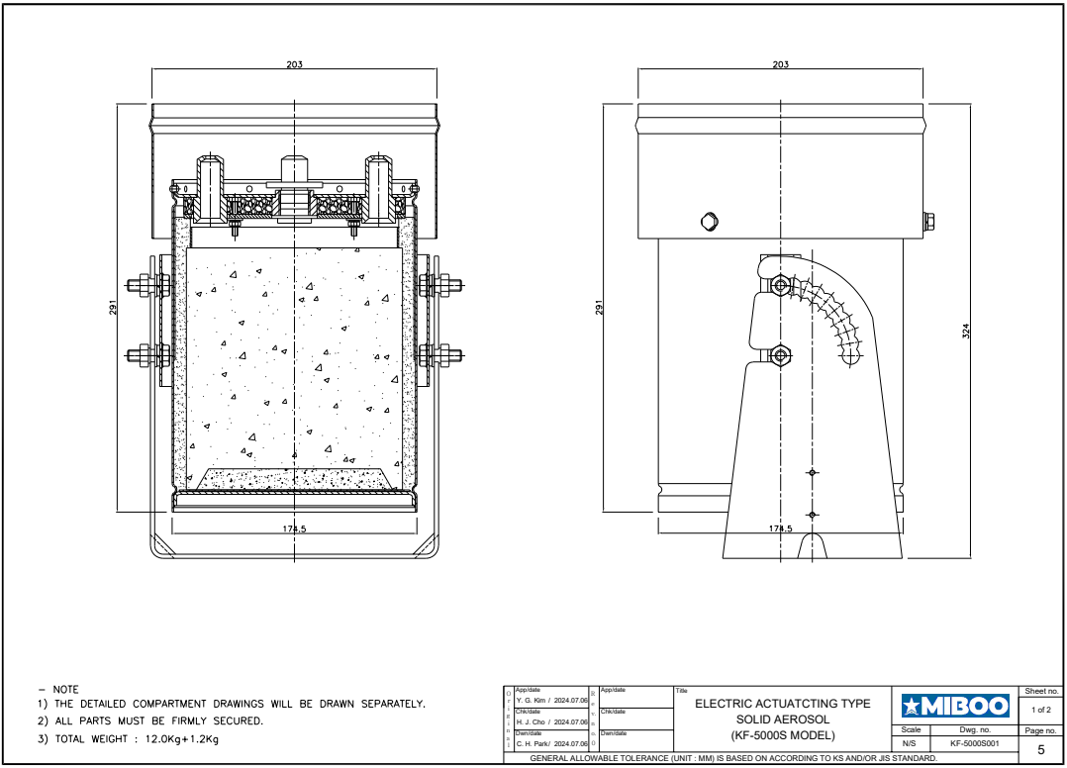

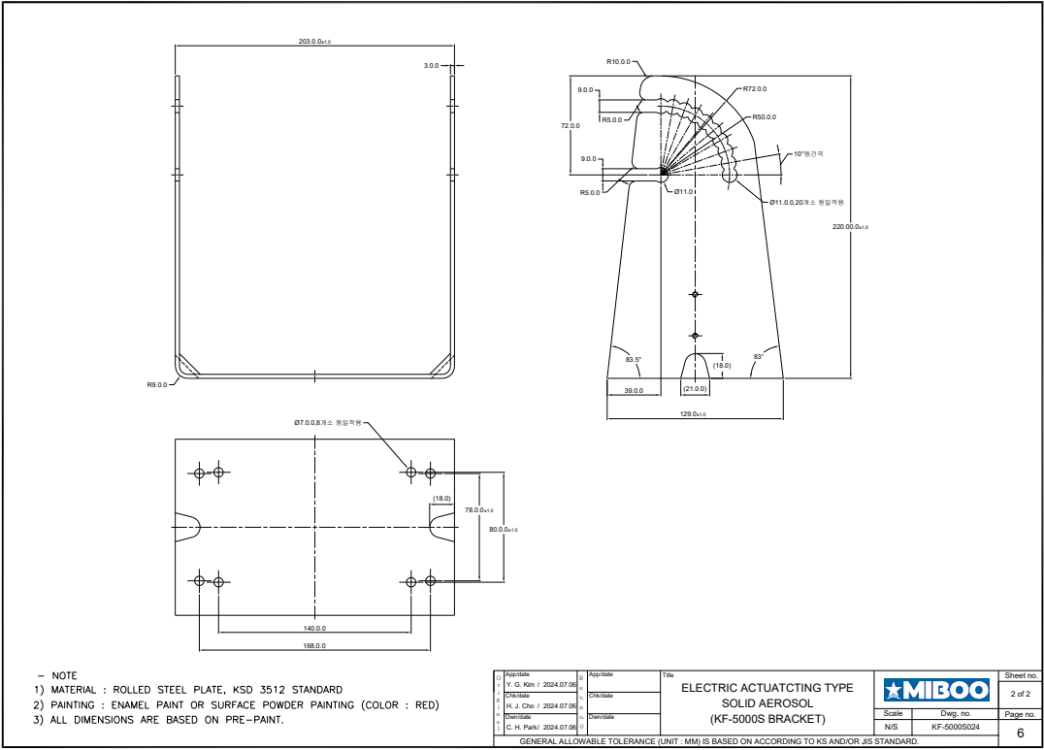

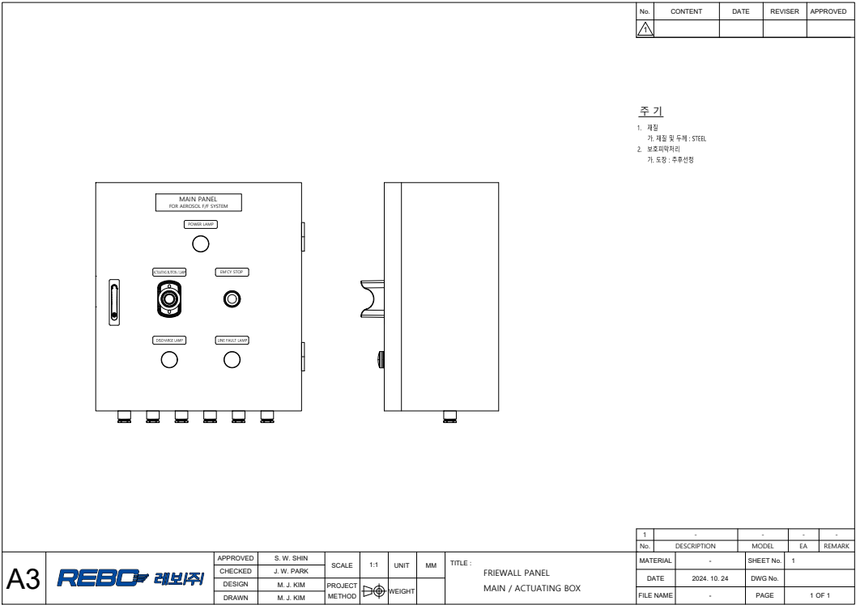

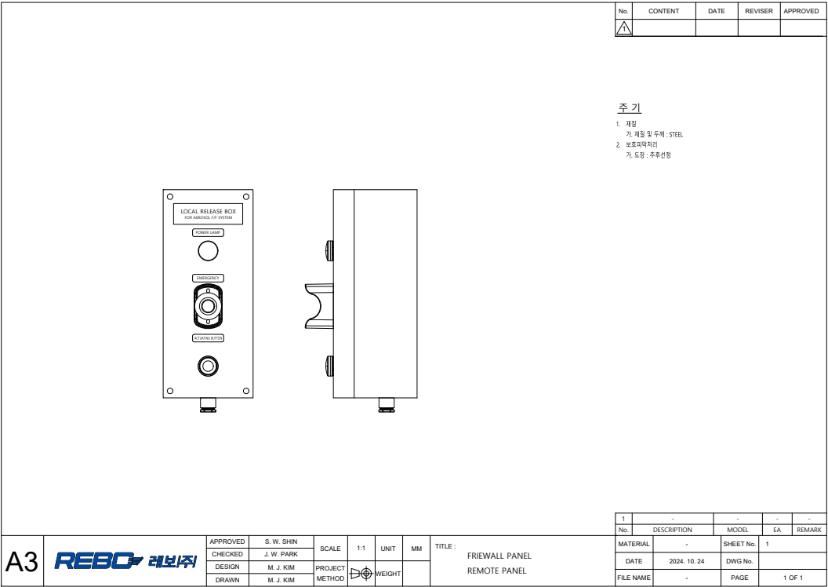

**9.0 Warranty**

**Limited Warranty Statement**

**We warrant this product to be free from defects in material and workmanship and will repair or replace any product or part thereof that proves to be defective in workmanship or material for a period of 18 months from the date of original shipment from our factory. Products with binding must be returned prepaid to the address below.**

**Hankook Miboo Corporation**

**82, Amnam Gongwon-ro, Seo-gu, Busan, South Korea**

**Website: www.hankukmiboo.co.kr Email: fire@miboo.co.kr**

**Tel : +82 (0)51-263-3621 Fax : +82 (0)51-263-3734**

**If the defect is caused by the user, we will repair it for a fee, and if it cannot be repaired, we will replace it with a new product and send it to you. The only way to resolve the defect is to repair or exchange it through Hankook US, and self-repair is not allowed and may be excluded from the warranty.**

**Limitation of Liability**

**This warranty does not apply to equipment that has been damaged in transit or by misuse, accident or negligence, or that has been altered by others. In no event shall Hankook U.S.A. be liable for any special or consequential damages, including damage to or loss of property or equipment, loss of profits or revenue, costs incurred, cost of purchased or replacement products, or customer claims by the original purchaser. The remedies set forth herein for the original purchaser and all other parties shall not exceed the value of the equipment provided.**

**this warranty is in lieu of all other warranties, express or implied, exclusive and express, including any warranties of merchantability or fitness.**

**Appendix-I**

**Safety/Publishing information**

**USMIT FIREWALL solid aerosol fire extinguishing systems use ignition devices. Personnel responsible for the extinguishing system must be aware of the potential hazards associated with improper handling, installation, or maintenance of this system.**

**Service personnel for the fire suppression system must be thoroughly trained in the proper handling, installation, and service of all equipment and components of the FIREWALL solid aerosol fire suppression system and must follow the instructions in the safety bulletins contained in this manual. HANKOOK MIBOO has provided appropriate warnings and cautions throughout the body of this manual. These warnings and cautions must be followed at all times; failure to do so could result in potential material and personal harm.**

**Safety Bulletin #1**

Environmental and Health Issues with FIREWALL Solid Aerosol Generators

**Environment**

There are no environmental concerns associated with using FIREWALL solid-state aerosol generators: both the Ozone Depletion Potential (ODP) and Global Warming Potential (GWP) are zero.

**Toxicity and health**

Solid-state aerosol generators do not pose a health hazard under normal atmospheric conditions because the constituent chemicals are compressed into a very stable solid form, even at high operating temperatures. This means that there is no environmental or health hazard from the chemicals in storage.

Unlike typical gaseous fire extinguishing agents, solid aerosols do not decompose in the presence of fire and are not extinguished by oxygen deprivation. FIREWALL solid aerosol fire extinguishing agents suppress fires through chemical reactions with "fire propagation" radicals (OH, H, O), which are essential elements in the spread of fire. FIREWALL solid aerosol generators rapidly interact with these active radicals within the fire zone to rapidly halt the ongoing fire reaction.

Solid aerosol fire extinguishing agents themselves are composed of solid and gaseous combustion products. The solid phase consists of highly dispersed salt particles and alkaline metal oxides, which pose negligible health risks to humans at typical design concentrations, while the gaseous phase may contain small amounts of carbon monoxide CO, carbon dioxide CO2, nitrogen oxides NOx, and ammonia NH3. The production of these gases is minimized because the extinguishing agent in FIREWALL solid aerosol generators is manufactured in Korea using only special construction, chemical formulations, technology, and reagent grade chemicals.

Experiments have shown no long-term negative effects from exposure to aerosol fire extinguishing agents. While the ingredients in aerosol fire extinguishing agents are not considered toxic at typical concentration levels, breathing in ultra-fine particles can cause short-term discomfort and unnecessary exposure should be avoided. Studies to date have shown that potential toxicity issues with aerosols are generally not due to the effects of solid particles, but rather related to potentially harmful products that may be produced in the gas phase (e.g., CO, NOx, etc.).

In particular, FIREWALL produces very little gas from aerosols, so its effect is negligible.

**In tests conducted by the Russian National Fire Research Institute (VNIIPO), solid aerosol fire extinguishing agents were considered to have the same acute toxicity as Halon 1301. Tests conducted by the Institute of Toxicology and Biophysics (Ministry of Public Health and Medicine of the Russian Federation) showed that the aerosol does not pose a health risk from limited accidental exposure at normal design concentrations. Exposure to aerosols is generally of less concern than exposure to decomposition products from fires. Accidental exposures of less than 5 minutes are generally considered safe; however, certain safety restrictions should always be observed. Exposure to aerosols should be avoided because breathing in ultrafine particles can cause short-term discomfort. In addition, the release of aerosols has a relatively high shielding factor.Therefore, the following system requirements should be observed**

**System installation requirements**

FIREWALL solid aerosol fire extinguishing systems must only be operated manually and in accordance with FSS CODE, using a 30-second time delay to ensure occupant evacuation prior to system activation.

**Safety Bulletin #2**

**Safe handling procedures for solid aerosol generators**

Before handling FIREWALL solid aerosol generators, all personnel must be thoroughly trained in the safe handling of the generator and the proper procedures for installation, removal, transportation, and disposal.

**Read, understand, and always follow** the operating and maintenance manuals provided with each individual piece of equipment**.**

The following safety procedures should always be followed

Upon delivery of the solid aerosol generator:

The solid aerosol generator must be shipped upright in the packaging it comes in. The solid aerosol generator must be properly secured in place and care must be taken not to roll or drop it. **A dropped generator must not be installed.**

Handling precautions:

Do not drop generators or allow them to run roughly against each other or other surfaces. Do not install a dropped generator.

Archive:

Storage should be in an upright position where it is not exposed to extreme environmental conditions or at risk of being knocked over.

**Safety Bulletin #3**

Post-fire treatment of solid aerosol generators

The released solid aerosol generator is partially recyclable.

You can dispose of the used generator in any landfill that accepts industrial waste. However, local regulations must be followed. Solid aerosol generator emissions include the following materials

1. Exterior/Interior Steel Construction
2. Fiberglass
3. Phenolic resins
4. Ignition wires
5. Trace chemicals

If you have any questions regarding the above, please contact the U.S. Department of State.

**General post #4:**

Equipment exposure issues with FIREWALL solid aerosol generators  
FIREWALL solid aerosol fire extinguishing agents have been tested on a wide range of materials, including electronics, structural, and aviation composites and materials commonly used in circuit boards. In all cases, FIREWALL solid aerosol fire extinguishing agents have been shown to have no detrimental effect on the ability of the equipment to operate.

**Extinguishing mechanisms**  
"Fire spreading" radicals (OH, H, O) are an essential element in the spread of fire. FIREWALL solid aerosol generators suppress fires primarily by chemical interference with these active radicals within the fire zone, blocking the ongoing fire reaction.

Potassium radical (K) is the main active ingredient in FIREWAL solid aerosol fire extinguishing agents. It is very active and reacts with these "diffusing radicals" just like the bromine radical in halon. The chemical reaction can be represented as follows, for example

K + OH = KOH  
koh + h = k + h2o  
K + OH, etc.

Flame propagation radicals also recombine on the surface area of ultrafine aerosol particulates, further impeding flame spread:

O + H = OH  
H + OH = H2O

**Aerosol Properties**

Due to their ultra-fine particle size and method of generation, the particulates are suspended for a long time and float with the gas/air mixture in the protected enclosure. Due to this "buoyancy effect", the aerosol does not "settle" for a long time and is therefore very easy to ventilate from the protected area. Only extremely small amounts of particulates can be deposited on equipment, and it is usually not necessary to do anything other than evacuate the air from within the protected area via a fan or air circulation system and then blow it out with compressed air. Particulates deposited on horizontal surfaces are µm or smaller and do not form a continuous layer; large gaps exist between particles, eliminating the possibility of electrical conductivity problems.  
  
However, as a precautionary measure, we recommend thoroughly inspecting and cleaning the site after discharge. While the aerosol itself is very "clean," environmental factors are also a consideration: unknown and potentially harmful byproducts of the actual fire pose the greatest risk to sensitive electronic equipment. It is always a good idea to air out or vacuum the equipment after discharge to ensure that no unwanted byproducts of combustion from the fire itself are present.  
Unlike HFCs, which can decompose and produce harmful compounds such as hydrofluoric acid when exposed to the high heat of a fire, FIREWALL solid aerosol fire extinguishing agents do not decompose when exposed to fire and are quickly extinguished through chemical interference with free radicals in the flame.

Components of FIREWALL Solid Aerosol

It is mainly composed by solidifying potassium compounds and carriers.(See MSDS)

FIREWALL Solids Aerosol has been tested on a wide range of sensitive materials, including real-world industrial applications. There have been no reports of adverse effects of aerosol components on electronic equipment or circuit boards. Proper installation of a FIREWALL solids aerosol fire extinguishing system will not harm electronic equipment and will not have a detrimental effect on the useful life of equipment exposed to FIREWALL solids aerosol.

**Appendix-II**

**MSDS: KF-5000S**

**MSDS No. AA03350-0000000013**

**1. information about the chemical and the company**

**1.1 Product name: "Marine" solid aerosol automatic fire extinguishing system KF-5000S**

Manufacturer product name

- Marine: KF-5000S

**1.2 Purpose of the Product and Limitations on Use**

Suggested Use: Use the product as directed by the manufacturer. Limitations of use: Refer to the product label or additional advice.

**1.3 Provider information**

Company Name : Korea Chemical Corporation

Address : 264, Chungmu-daero, Seo-gu, Busan (Chungmu-dong 1-ga) Phone : 051-256-1771

Fax: 051-256-7336

Website address : www.kpyro.com Emergency phone number : 051-256-1771

**2. Hazard - Risk**

**2.1 Hazards - Risk Classification**

Oxidizing Solids: Classification 3

Acute Toxicity (Hop Inhalation: Dust/Mist): Category 3

Skin corrosive/irritant: Category 2

Severe eye damage/irritation: Category 2 (2A/2B)

Skin Hypersensitivity: Category K1A/1B））

Reproductive toxicity: Category 1B

Specific target organ toxicity (1 exposure): Category 2

Specific target organ toxicity (1 exposure): Category 3 (Respiratory irritation)

Specific target organ toxicity (repeated exposure): Category 2

**2.2 Warning sign items with precautionary statements**

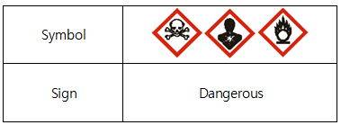

**Hazardous - Warning Statements**

H228 Flammable solid

H272 Intensifies fire.

H315 Causes skin irritation.

H317 May cause allergic skin reactions.

H319 Causes severe eye irritation.

H331 Toxic if hopped.

H335 May cause hopper irritation.

H360 Can cause fetal or reproductive harm.

H371 May cause organ damage.

H373 May cause damage to organs through prolonged or repeated exposure.

H411 Toxic to aquatic life by long-term effects.

**Precautionary statements**

**Prevention**

P201 Obtain the instruction manual before use.

P202 Do not handle until you have read and understood all safety precaution statements.

P210 Keep away from heat, hot surfaces, sparks, flames, and other sources of ignition.

P220 Keep away from clothing and other flammable materials.

P260 Do not breathe dust/inhale/gas/mist/vapor/spray.

P261 Avoid breathing dust/inhaling/gases/mists/vapors/sprays

Wash contact areas thoroughly after handling the P264.

P270 Do not eat, drink, or smoke when using this product.

P271 Handle only outdoors or in a well-ventilated area.

P272 Do not take contaminated work clothing out of the workplace.

P273 Do not discharge to the environment.

P280 Wear protective gloves/protective clothing/goggles/face protection.

**Correspondence**

P302+P352 If contact with skin occurs, flush with plenty of water.

P304+P340 If inhaled, remove to fresh air and keep at rest in a position that allows easy breathing.

P305+P351+P338 In case of contact with eyes, flush carefully with water for several minutes.

Remove contact lenses if possible and continue to wash.

P308+P311 If exposed or concerned about exposure, get Z!char from a healthcare provider.

P308+P313 Get medical attention if exposed or concerned about exposure.

P311 Seek medical attention.

P312 Seek medical attention if you feel unwell.

P314 If you feel unwell, seek medical attention.

P321 Provide appropriate treatment.

P332+P313 Get medical attention if skin irritation occurs.

P333+P313 Get medical attention if skin irritation or erythema occurs.

P337+P313 If eye irritation persists, get medical attention.

P362+P364 Remove contaminated clothing and wash before reuse.

P371+P380+P375 In the event of a large fire, evacuate the surrounding area and keep a distance from the fire due to the risk of explosion.

**Save**

P403+P233 Store containers tightly closed in a well-ventilated area. P405 Store in a locked container.

**Discard**

P501 Dispose of contents/container in accordance with waste laws.

**2.3 Other Hazards and Risks Not Included in the Hazard Classification**

**No data**

**3. Ingredient names and content**

|  |  |  |  |
| --- | --- | --- | --- |
| Substance name | Aliases (common names) | CAS number | Remarks |
| Potassium Nitrate | -. | 7757-79-1 |  |
| Cyanuric acid | 1，3,5-Triazine一2,4,6(1H,3H,5H)-trione ( 1,3,5-TRIAZINE-2,4,6(1 H,3H,5H)-TRIONE | 108-80-5 |  |
| Araldite Resin  (Poly(Araldit Resin G2)) | Bisphenol- A-(Epichlorohydrin)  Epoxy resin | 25068-38-6 |  |
| Phenolic resin | Contains Phenolic Polymers Formaldehyde (Phenol, Polymer  with formaldehyde) | 9003-35-4 |  |
| Sodium carboxymethyl cellulose | Cellulose,  carboxymethylether , Sodium salt | 9004-32-4 |  |
| Basic Magnesium Carbonate (BASIC MAGNESIUM CARBONATE) | Carbonic Acid, Magnesium Salt (1:1), Mixed,  Magnesium Hydroxide  (MG(OH)2), Hydrate | 39409-82-0 |  |
| Boric acid | Boric acid (h3bo3) | 10043-35-3 |  |
| Calcium Sulfate, Dihydrate | SULFURIC  ACID, CALCIUM SALT(1:1),  DIHYDRATE | 10101-41-4 |  |
| Silicon oxide | SILICA | 7631-86-9 |  |
| Calcium stearate |  | 1592-23-0 |  |

**4. First aid tips**

**4.1 First Aid**

**4.1.1 When in sight**

In case of contact with eyes, flush carefully with running water for at least 15 minutes.

If you are wearing contact lenses, remove them before washing, if possible. Seek medical attention and advice if eye irritation persists.

**4.1.2 When in contact with skin**

Wash thoroughly with lukewarm water and soap in case of skin contact.

Remove contaminated clothing and wash it before using it again.

If skin irritation occurs, seek medical advice.

**4.1.3 When Hopped In**

Move to fresh air, rest, warm up, change clothes, flush with warm water, and seek medical attention if necessary.

**4.1.4 When eaten**

Splash your mouth with water.

Drink plenty of water, activated charcoal/saline laxatives/milk.

See a doctor.

**4.2 Acute, delayed symptoms and effects**

**4.2.1 When in sight**

Tearing, pain, swelling

**4.2.2 When in contact with skin**

Dryness, erythema pain

**4.2.3 When Hopped In**

Headache, sweating, thirst, shortness of breath

**4.2.4 When eaten**

Headache, nausea, vomiting, abdominal pain, hot flashes, shortness of breath, decreased blood pressure, cramps, diarrhea

**5. What to do in case of an explosion or fire**

**5.1 Appropriate fire extinguishing agents**

This product is a fire extinguishing product and all fire extinguishing agents are applicable, including volumetric fire extinguishing with water and dry fire extinguishing agents.

**5.2 Specific hazards from chemicals**

In the event of a fire, the charging block ignites and burns, releasing a large amount of extinguishing aerosol.

**5.3 Protective Gear and Precautions to Wear When Fighting a Fire**

Combustion products formed at the scene of a fire exist in two states: 52% solid and 48% gaseous. The solid phase remaining after combustion of the composition exhibits an alkaline reaction, causing chemical burns to the skin and eyes. Always wear personal protective equipment and clothing in areas where fire is occurring.

**6. What to do in case of a leak**

**6.1 Measures and protective gear needed to protect humanitol**

A. Actions

Maintain adequate ventilation.

Follow fire safety measures (no smoking).

Eliminate sources of fire and sparks.

B. Protective Gear

See Personal Protective Equipment in Section 8.

**6.2 What you need to do to protect your environment**

Prevent substances from entering surface waters.

**6.3 How to cleanse or remove**

Cover the material with sand or other inert material and collect in a dry container.

Dispose of in accordance with fire safety measures.

Isolate the material with sand and dry it with plenty of water to prevent the material from entering surface water.

**7. handling and storage**

**7.1 Safe handling tips**

Treat it as a combustible material that can burn without access to air.

Do not handle until you have read and understood all safety precaution statements.

**7.2 Secure storage methods**

Store in a covered, dry, well-ventilated, unheated area with a relative humidity of 85% or less. Store products in tacks or stacks using the manufacturer's packaging and stacked no higher than 3 tiers for cardboard boxes and 1.5 meters for wooden boxes.

Store in a well-ventilated area. Do not open before use.

**8. Exposure Prevention and Personal Protective Equipment**

**8.1 Chemical Exposure Criteria, Biological Exposure Criteria, etc.**

Domestic: No data available

Limit union exposure to the work environment: no materials

Tracking : No data

Biological Exposure Criteria: No data available

**8.2 Proper engineering care**

Ventilate during handling to keep air contamination below exposure limits.

**8.3 Personal Protective Equipment**

|  |  |  |
| --- | --- | --- |
|  | **Respiratory protection** | Use a mask for respiratory protection. |
|  | **Eye protection** | Use chemical protective eyewear and safety face shields. |
|  | **Hand protection** | Wear appropriate heat-resistant gloves. |
|  | **Protect your body** | Wear appropriate protective clothing. |

**9. physicochemical properties**

|  |  |
| --- | --- |
| A. Appearance | Appearance: Solid  Color: Gray and Beige |
| B. Odor | Odorless |
| C. Odor Threshold | No data |
| D. pH | No data |
| E. Melting point / freezing point | No data |
| F. Initial boiling point / boiling point range | No data |
| G. Flash point | No data |
| H. Evaporation rate | No data |
| I. Flammable (solid, gaseous) | Flammable solids |
| J. Upper/lower limit of flammable or explosive range | No data |
| K. Vapor pressure | No data |
| L. Solubility | Insoluble |
| M. Vapor Density | No data |
| N. Specific Gravity | No data |
| O. N-Octanol/Water Partition Coefficient | No data |
| P. Spontaneous combustion temperature | 500°C or higher |
| Q. Decomposition temperature | No data |
| R. Viscosity | No data |
| S. Molecular Weight | No data |
| T. Density | 1700 Kg/m³ |
| U. Impact sensitivity | 40 J |
| V. Friction semstivity | 3600 |
| W. Compressive strength | 40 Mpa |

**10. stability and responsiveness**

**10.1 Chemical Stability and Potential for Hazardous Reactions**

Stable when handled and used under recommended conditions.

**10.2 Conditions to avoid**

Avoid contact with ignition sources and flammable materials, as well as product fumes generated during use.

**10.3 Substances to Avoid: No Material**

**10.4 Hazardous substances produced during decomposition: see section 3.1**

**11. information about toxicity**

**11.1 Information about likely routes of exposure**

|  |  |
| --- | --- |
| Potassium Nitrate | No data |
| Boric acid | Irritation, skin disorder, blood pressure changes, nausea, vomiting, diarrhea, stomach pain, irregular heartbeat, headache, drowsiness, dizziness, tremor, coordination (function) loss, visual disturbances, cyanosis, internal heat, kidney abnormalities, convulsions, coma, loss of memory.  No information on serious side effects. |
| Calcium Sulfate, Dihydrate | No data |
| Cyanuric acid | Can be taken into the body by inhalation.  May be absorbed by the body by inhalation and digestion. May be ingested  through skin, digestive tract and aerosol. May be absorbed by the body by inhalation of vapor. May be  absorbed by body by inhalation, skin, digestive system. |
| Araldite Resin (Poly(Araldit Resin G2)) | May irritate respiratory tract.  May irritate skin.  May irritate eyes. |
| Silicon oxide | No data |
| Sodium Carboxymethyl Cellulose (sodium carboxymethylcellulose) | No data |
| phenolic resin | No data |
| Basic Magnesium Carbonate (basic magnesium carbonate) | No data |
| Calcium stearate | Irritation  Gastrointestinal Disorders |

**11.2 Health Hazard Information**

**A. Acute Toxicity**

|  |  |  |  |  |  |
| --- | --- | --- | --- | --- | --- |
| Separation | Acute Toxicity Estimates (ATEmix) | | | | Categorize |
| **Oral** | 1093.65 mg/kg | | | | Division 4 |
| **Transdermal** | 24.22 mg/kg | | | | Division 2 |
| **Suction** | Dust or Mist | | 0.0027 mg/L | | Division 1 |
|  |  |  |  |  |  |
| Potassium Nitrate | | | DL50 > 2000 mg/kg, oral, rat  DL50 > 5000 mg/kg, skin, rat  DL50 > 0,527 mg/l, 4 hours, rat | | |
| phenolic resin | | | DL50 > 5000 mg/kg, oral, rat  DL50 > 2000 mg/kg, skin, rat  DL50 > 7570 mg/l, 2 hours, rat | | |

**B. Corrosive or irritating to skin**

|  |  |  |  |
| --- | --- | --- | --- |
| Material name | Test animals | Test results | Test Methods |
| Potassium Nitrate | Rabbit | No irritants found. | OECD Guideline 404 |
| Boric acid | Guinea pigs | Moderately irritating. | No data |
| Calcium Sulfate, Dihydrate | Rabbit | Appears to be non-irritating. | No data |
| Cyanuric acid | Rabbit | primary dermal irrirarion  index (PDII): 0/8,  not applicable to GHS classification. | OECD TG 44 |
| Araldite Resin  (Poly(Araldit Resin G2)) | Rabbit | Classification in the EU WT 7th Revised Annex1  is R38 (Causes skin irritation.)  Moderate irritation in the STANDARD DRAISE TEST. | CERI Harzard Data  2002 |
| Silicon oxide | Rabbit | Light stimulation | No data |
| Sodium Carboxymethyl Cellulose | No data | | |
| phenolic resin | No data | | |
| Basic Magnesium Carbonate | No data | | |
| Calcium stearate | No data | | |

**C. Severe eye damage or irritation**

|  |  |  |  |
| --- | --- | --- | --- |
| Material name | Test animals | Test results | Test Methods |
| Potassium Nitrate | Rabbit | No irritation found.  Full recovery within 2 hours.  (Conjunctival index: 0.7 (redness),  0.3 (conjunctival edema), 0.3 (discharge)) | OECD Guideline 405 |
| Boric acid | Human | Irritation reported. | No data |
| Calcium Sulfate, Dihydrate | No data | | |
| Cyanuric acid | Rabbit | Does not meet GHS classification criteria.  Fully reversible within 3 days | OECD TG 405 |
| Araldite Resin  (Poly(Araldit Resin G2)) | Rabbit | Eye irritant.  Moderate to severe irritation in the STANDARD DRAIZE TEST. | CERI Harzard Data  2002 |
| Silicon oxide | No data | | |
| Sodium Carboxymethyl Cellulose | No data | | |
| Phenolic resin | Albino  rabbit | I find it a little irritating Tanam (10.6 out of 110) | Draize et,al. |
| Basic Magnesium Carbonate | No data | | |
| Calcium stearate | No data | | |

**D. Respiratory hypersensitivity: no data available**

**E. Skin sensitivity**

|  |  |  |  |
| --- | --- | --- | --- |
| Material name | Test animals | Test results | Test Methods |
| Potassium Nitrate | Rats (female) | No hypersensitivity found. | OECD Guideline 429 |
| Boric acid | No data | | |
| Calcium Sulfate, Dihydrate | Guinea pig | Did not cause skin sensitization. | Buehler test |
| Cyanuric acid | Rats (female) | Mildly hypersensitive,Rats,  Local Lymph Node Assay (LLNA),GLP | OECD TG 429 |
| Araldite Resin  (Poly(Araldit Resin G2)) | No data | The classification of the European Union WG 7th Revised Annex1 is R43 ( May cause sensitization by skin contact.) | No data |
| Silicon oxide | No data | No skin sensitivities. | No data |
| Sodium Carboxymethyl Cellulose | No data | | |
| Phenolic resin | Human | After two years, skin eczema was observed to be induced, and triple plus (3+. Extreme reaction) results were observed for Chemotechnique (2.5 and 5% in petrolatum) and Hemnal Cherrie (5% etrolatum). Also Acute exposure of mold workers to these substances has been reported to result in dermal eczema after 1 week on the body.  Based on the above, it is considered to be in skin sensitization category 1. | Allergy Patch Test  EU REACH  List of allergens |
| Basic Magnesium Carbonate | No data | | |
| Calcium stearate | No data | | |

**F. Carcinogenicity: No data available**

**G. Germline mutagenicity**

|  |  |  |  |
| --- | --- | --- | --- |
| Material name | Test animals | Test results | Test Methods |
| Potassium Nitrate | Mammals | Negative with or without metabolic activity. ( E-mutation test results) Negative without metabolic activator.  (Chromosomal test result) | OECD  Guideline 476  OECD Guideline 473 |
| Boric acid | Dominant Lethality Phagocytic  somatic cell | Voice | No data |
| Calcium Sulfate, Dihydrate | Rats | Negative  (Mammalian erythrocyte  micronucleus test) | IN VIVO-Type :  Mammalian erythrocyte micronucleus test |
| Cyanuric acid | Bacteria | in vitro - revertant mutation test with bacteriol : negative. (S. typhimurium TA1535, regardless of metabolic activity) | OECD TG 471, EU Method  B. 13/14, EPA OPPTS  870.5100,GLP |
| Araldite Resin  (Poly(Araldit Resin G2)) | Mammalian cells  (Rats lymphoma  L5178Y cells) | When studying gene mutations,  a positive observation, regardless of whether it is metabolically active or not, is insufficient for classification. | No data |
| Silicon oxide | No data | | |
| Sodium Carboxymethyl Cellulose | No data | Voice, with or without metabolizers. | In vitro Salmonella  typhimurium Ames test |
| phenolic resin | No data | | |
| Basic Magnesium Carbonate | No data | | |
| Calcium stearate | No data | | |

**H. Reproductive toxicity**

|  |  |  |  |
| --- | --- | --- | --- |
| Material name | Test animals | Test results | Test Methods |
| Potassium Nitrate | Rats  (Female/  Male) | There were no deaths，Slight increase in blood nitrogen, impaired renal function，Uterine (horns) - dilatation seen. (NOAEL>= 1 500 mg/kg bw/day) (Reproductive toxicity test results) | OECD  Guideline 422 |
| Rats | No deaths, uterine dilatation seen in female rats. (NOAEL>= 1 500mg/kg bw/day) (Developmental toxicity/teratogenesis) | OECD 422 |
| Boric acid | No data | Causes abnormalities in reproductive function and affects the development of offspring. | No data |
| Calcium Sulfate, Dihydrate | Rats | No significant difference between treatment and control groups (reproductive toxicity study) | No data |
| Cyanuric acid | Rats | There were no biologically adverse effects on parental fertility or on the growth and development of the offspring.No teratogenic effects. (onosodium cyanurate at dose levels below 5000 mg/kg/day - oral administration) High- dose sodium controls,malformed fetuses in pups with bent ribs Increased incidence. | equivalent or similar to Guideline： EU Method B.35 EU Method B.31, GLP |
| Araldite Resin  (Poly(Araldit Resin G2)) | No data | | |
| Silicon oxide | No data | | |
| Sodium Carboxymethyl Cellulose | No data | | |
| Phenolic resin | Osborne Mendel rats (Male or Female) | 0, 5000, 10000, or 20000 ppm 0, 250, 500 or 1000mg/Kg bw)  Dose,Oral administration for 2 years In a reproductive toxicity study,  no clinical signs or premature deaths were observed; no abnormalities were observed in testicular weights of rats treated with 1000 mg/Kg bw.  (NOAEL = 1000mg/Kg bw as deemed) | No data |
| Basic Magnesium Carbonate | No data | | |
| Calcium stearate | No data | | |

**I. Specific target organ toxicity (single exposure)**

|  |  |  |  |
| --- | --- | --- | --- |
| Material name | Test animals | Test results | Test Methods |
| Potassium Nitrate | Human | May cause irritation to the respiratory tract. (Acute Toxicity Exposure Test Results) | No data |
| White  Rats | Methemoglobinemia is present， producing methemoglobin, Stimulate the airway. | No data |
| Boric acid | Human | Digestive tract symptomssuch as vomiting, abdominal pain, and diarrhea; central nervous system symptoms such as drowsiness, headache, fever, skin irritation, and muscle spasms; irritation of the upper respiratory tract; and in experimental animals, limb loss. Symptoms of stiffness, convulsions, or shock. | No data |
| Calcium Sulfate, Dihydrate | No data | | |
| Cyanuric acid | Rats  (Female/  Male) | Oral: Clinical abnormalities were observed in 2 individuals of one of each sex, including lack of fecal fire in both animals and sedation, ataxia, and porphyria around the mouth and nose.  With the exception of weight loss, these effects subsided by day 4 post-dose.  Border: No clinical signs. One female exhibited pale kidneys, pale and mottled kidneys, and tapeworm ovaries. No effects were attributed to toxicity of the test substance.  Hoppers: Prominent observed symptoms included decreased activity and hair loss. 5 Recover on Day 1. | OECD TGI 420  oecd tgi 403 / gap |
| Araldite Resin  (Poly(Araldit Resin G2)) | No data | | |
| Silicon oxide | No data | | |
| Sodium Carboxymethyl Cellulose | No data | Irritates the airways when inhaled. |  |
| Phenolic resin | No data | | |
| Basic Magnesium Carbonate | No data | | |
| Calcium stearate | No data | | |

**J. Specific target organ toxicity (repeated exposure)**

|  |  |  |  |
| --- | --- | --- | --- |
| Material name | Test animals | Test results | Test Methods |
| Potassium Nitrate | Human | (28 days) Slightly increased blood nitrogen, concentrations, impaired renal function, and dilated uterus (NOA Tao1,500 mg/kg bw/day) (Chronic oral toxicity study) | OECD TGI 422 |
| White  Rats | (4 weeks) Thyroid weight increased, serum levels  increased as did iodine excretion levels, and hypothyroidism was noted (chronic toxicity exposure test). | No data |
| Boric acid | Human | Causes kidney failure, including oliguria, anuria, and necrosis of the tubules. | No data |
| Calcium Sulfate, Dihydrate | No data | | |
| Cyanuric acid | Rats  (female  /male) | Oral (Aman Sung): LOAEL (CYA) >521 mg/kg bw/d (m) > 717 mg/kg bw/d (f), NOAEL (CYA)=521 mg/kg bw/d (m) 717 mg/kg bw/d ⑴ | oecd tgi 407 / gap |
| Araldite Resin  (Poly(Araldit Resin G2)) | No data | | |
| Silicon oxide | People | Quartz and cristobalite have been reported to cause silicosis in humans. In laboratory animals, quartz and cristobalite have also been reported to have the potential to form oily oils. | No data |
| Sodium Carboxymethyl Cellulose | No data | | |
| phenolic resin | No data | | |
| Basic Magnesium Carbonate | No data | | |
| Calcium stearate | No data | | |

**K. Aspiration hazard: no data available.**

**12. Environmental impact**

|  |  |
| --- | --- |
| 12.1 Ecotoxicity | : No data |
|  |  |
| 12.2 Persistence and Degradability | : No data |
|  |  |
| 12.3 Bioconcentrability | : No data |
|  |  |
| 12.4 Soil Mobility | : No data |
|  |  |
| 12.5 Other Trending Influences | : No data |

**13. Disposal precautions**

**13.1 Disposal Methods**

Something to dispose of as solid waste.

Dispose of flammable materials according to regulations.

For disposal, contact an authorized waste handler or manufacturer/supplier for disposal.

**13.2 Disposal Precautions**

Dispose of in accordance with applicable laws and regulations and manufacturer's instructions.

**14. information required for shipping**

**14.1 Fire extinguishing aerosol generators**

14.1.1 United Nations Number (UN No.): 3363

14.1.2 UN Proper Shipping Name: DANGEROUS GOODS IN APPARATUS

14.1.3 Hazard class in transportation: 9

14.1.4 Vessel Class: 962

14.1.5 Marine pollutants: N/A

14.1.6 Special safety measures: see section 2

14.2 Fire extinguishing aerosol generators in special package

14.2.1 United Nations Number (UN No.): 3178

14.2.2 UN Proper Shipping Name: Flammable solid, inorganic, n.o.s.

14.2.3 Hazard class in transportation: 4.1

14.2.4 Vessel Class: III

14.2.5 Marine pollutants: N/A

14.2.6 Special safety measures: see section 2

**15. Legal and regulatory status**

**15.1 Regulation under the Occupational Safety and Health Act :** Article 104, Articles 110~116, Enforcement Decree 86, Enforcement Rule 114

**15.2 Regulation under the Chemical Control Act :** No data available

**15.3 Regulation under the Dangerous Wool Safety Management Act :** Not available

**15.4 Regulation under the Waste Management Act:** No data available

**15.5 Regulation by Other National and Foreign Laws**

- Ministry of Labor and Employment Notification No. 2020-130 ('21.01.16) Standards for Classification, Labeling and MSDS of Chemicals

- Classification under the International Dangerous Goods Road Transport Regulations [ADR]

- KCL OECD Guideline 404, 405, 423 GAP Final Report, Ministry of Employment and Labor Notice 2020-130

- HAZARD CLASSIFICATION OF UNITED STATES MILITARY EXPLOSIVES AND MUNITIONS U.S.ARMY DEFENSE AMMUNITION CENTER LOGISTICS REVIEW and TECHNICAL ASSISTANCE OFFICE(REVISION 15, JUNE 2012)

**16. other notes**

**16.1 Sources of material**

A. Chemical safety information: MSDS from Korea Occupational Safety and Health Administration (KOSHA) B. Transportation regulations: Classification according to the International Dangerous Goods Road Transport Regulations [ADR]

**16.2 First Published:** January 12, 2024

**16.3 Revision Count and Last Revision Date**

A. Number of revisions: 0

B. Last Revised: 01/12/2024

**16.4 Other**

The information contained in this publication or otherwise made available to you is believed to be accurate and reliable, but you are confirming the suitability of the product for your particular purposes.

this product makes no warranties as to the fitness of the product for any particular purpose and any implied warranties or conditions (where expressly stated by law) are excluded except to the extent their exclusion is prohibited by law.

This product shall not be liable for any loss or damage (other than loss resulting from death or personal injury caused by a defect in the product) arising from reliance on this information.

**Appendix-III**

**Toxicity test results**

**(Excerpted results only)**

**Acute oral toxicity testing**

**Eye irritation and serious eye damage tests**

**Ozone Depleting Substances Testing**

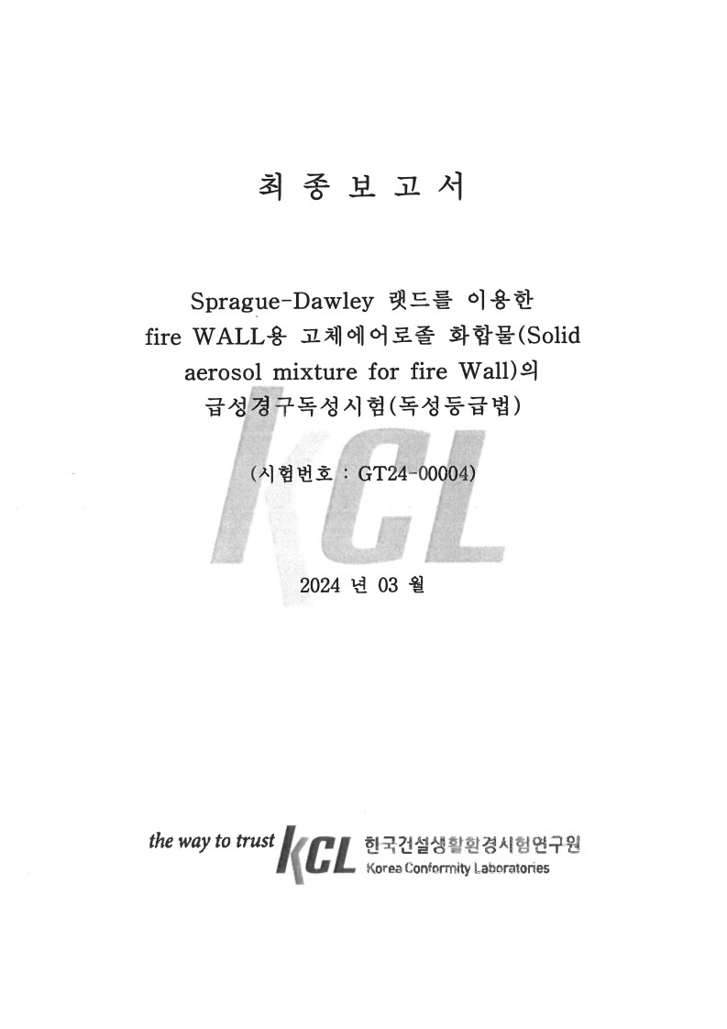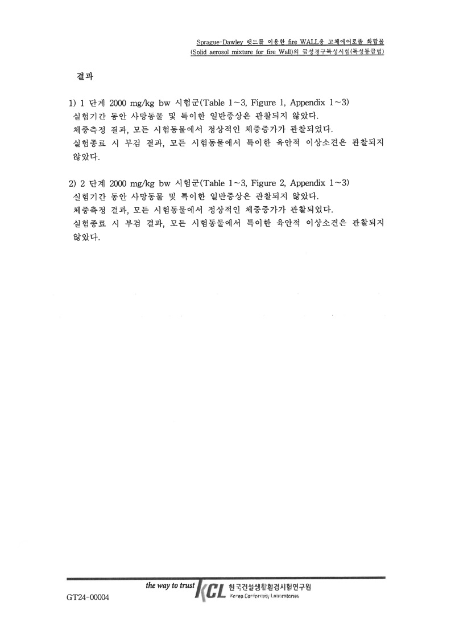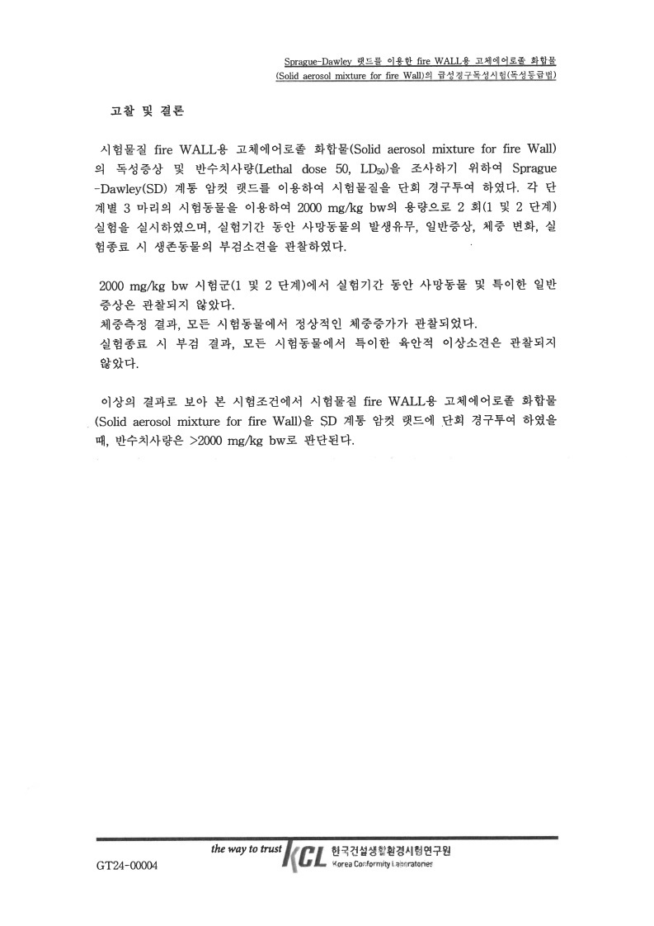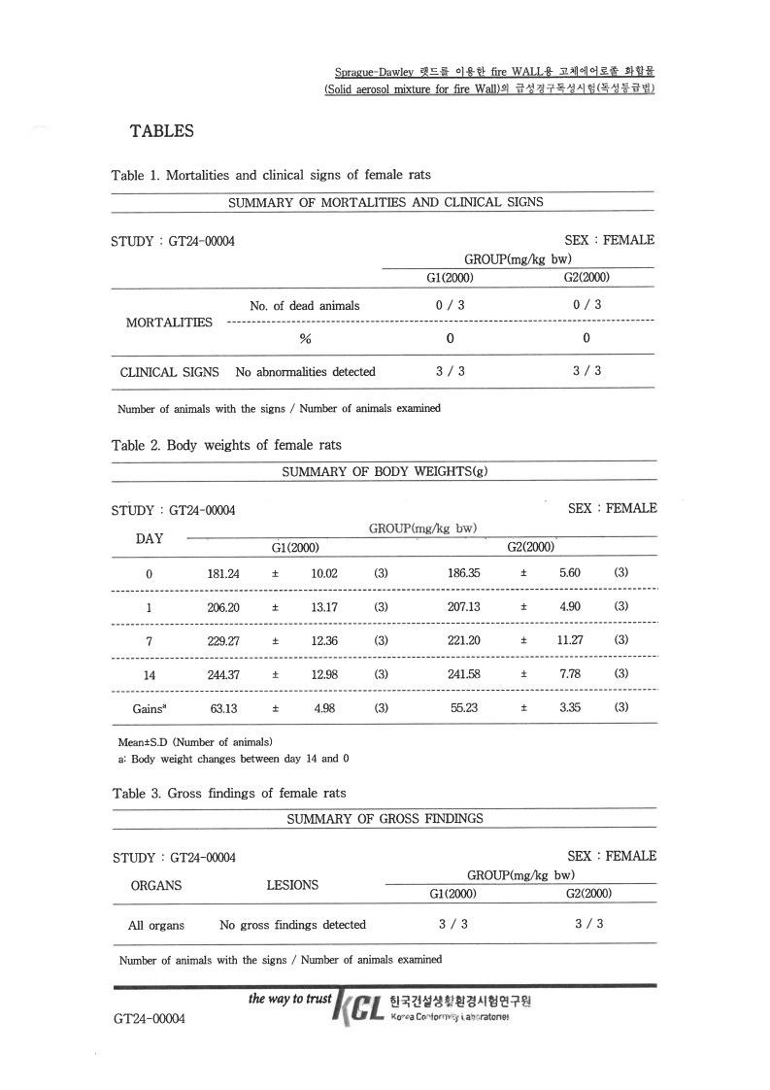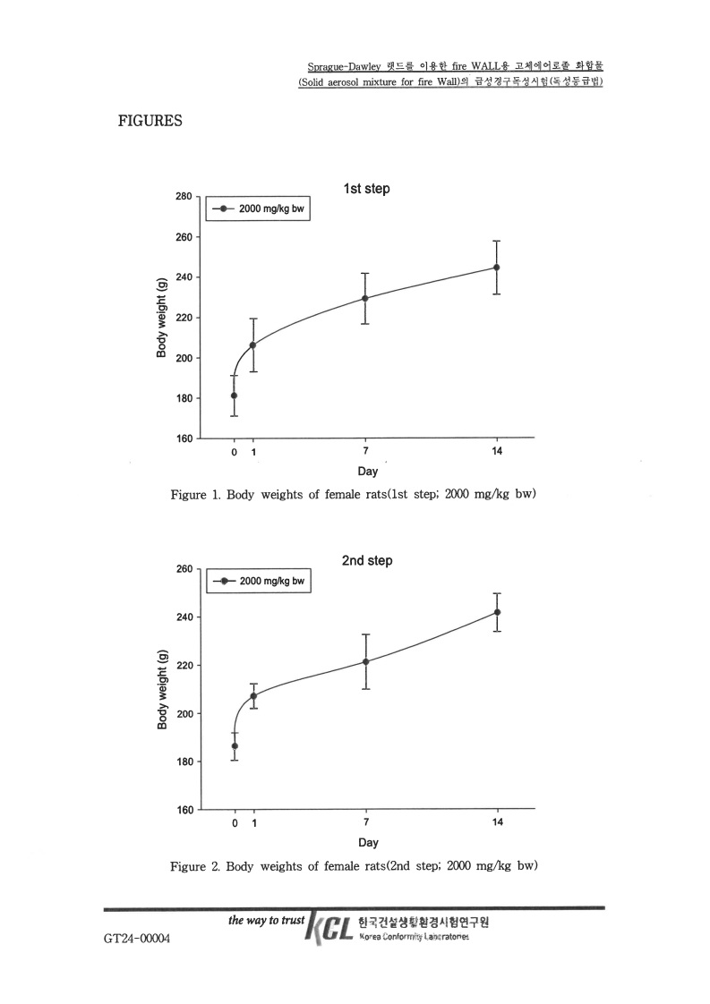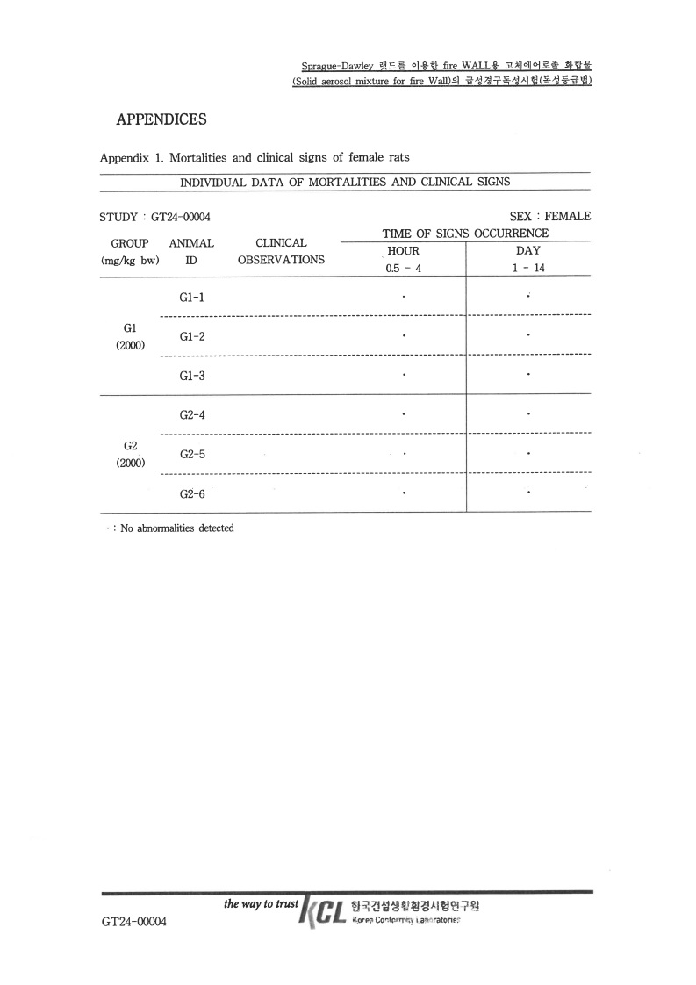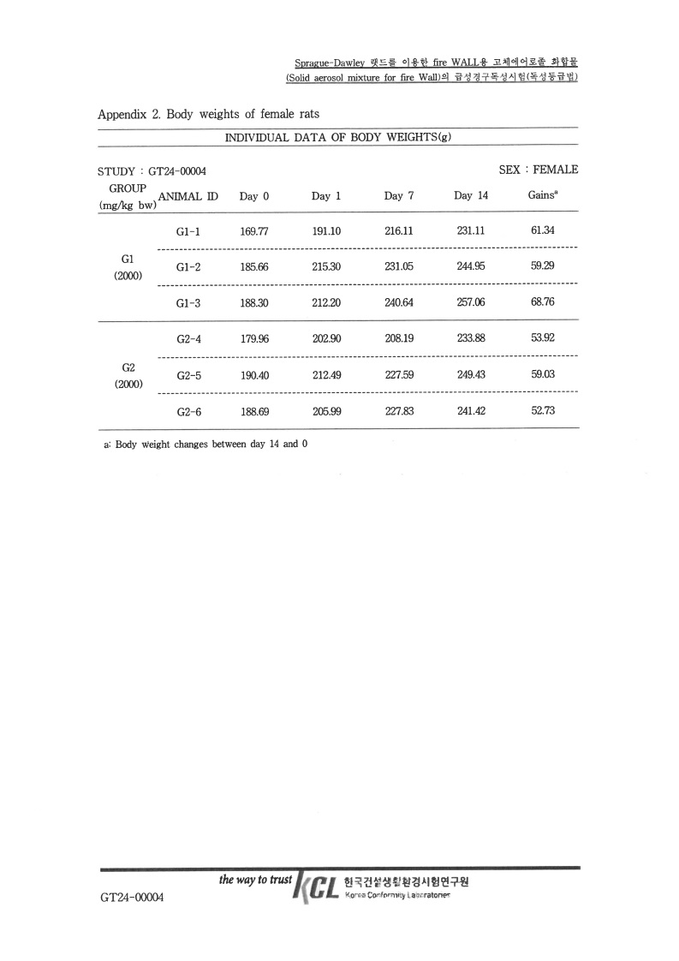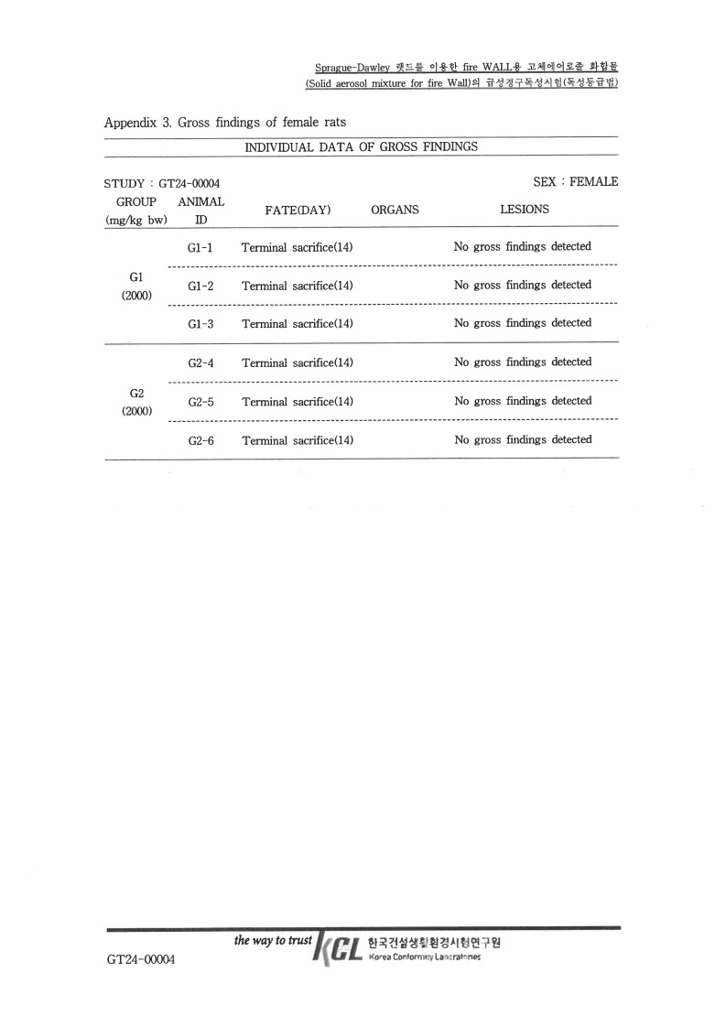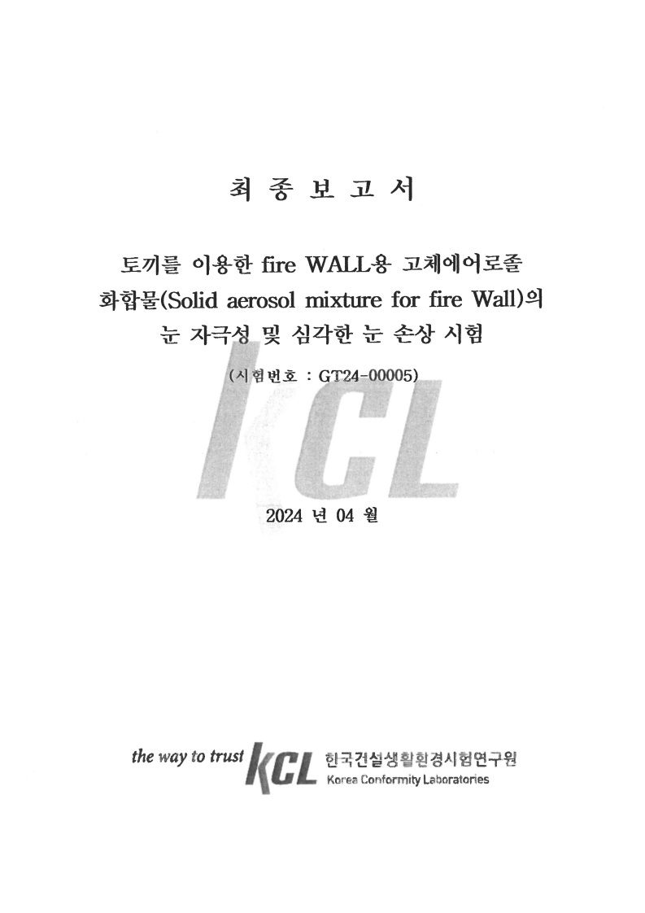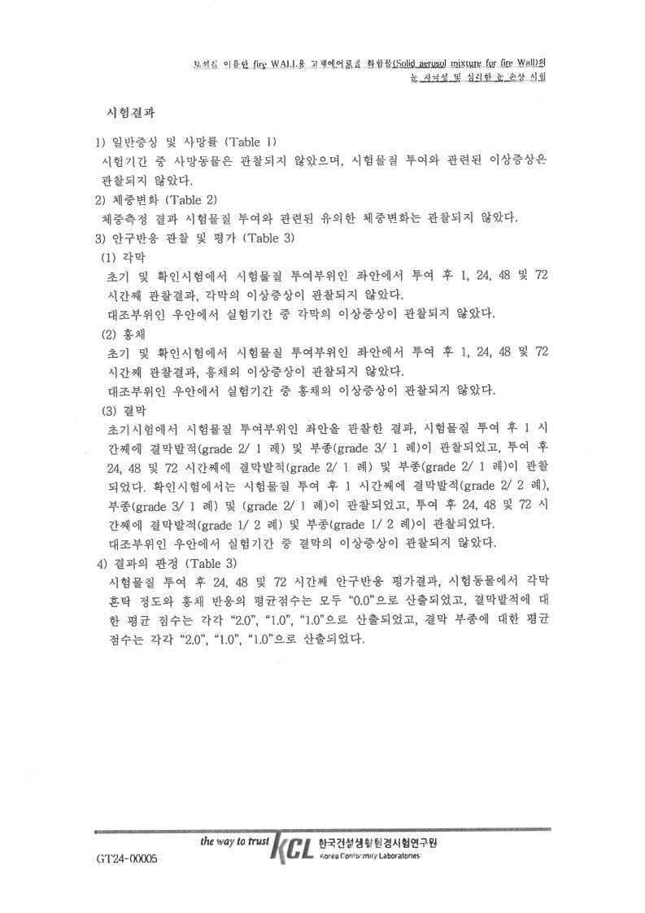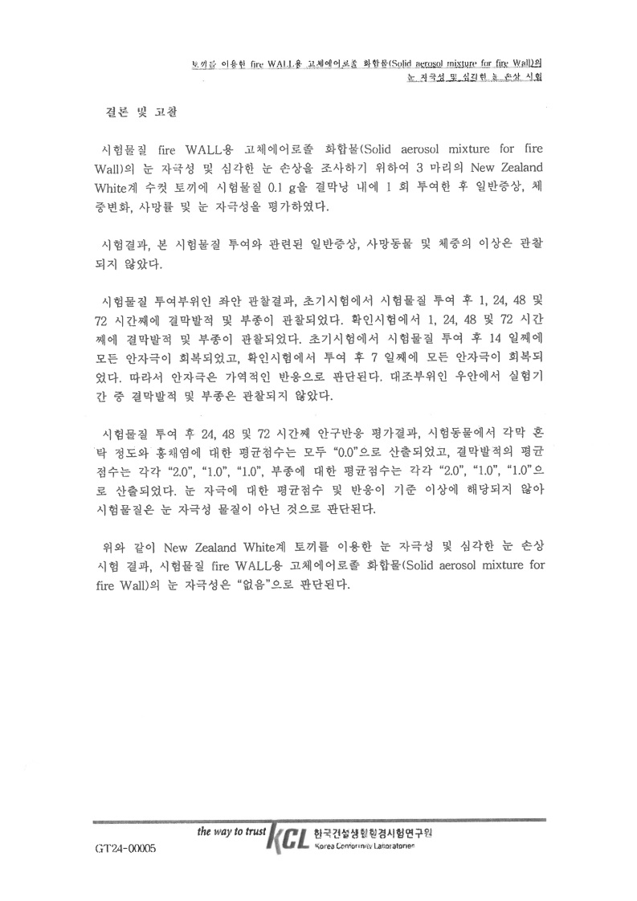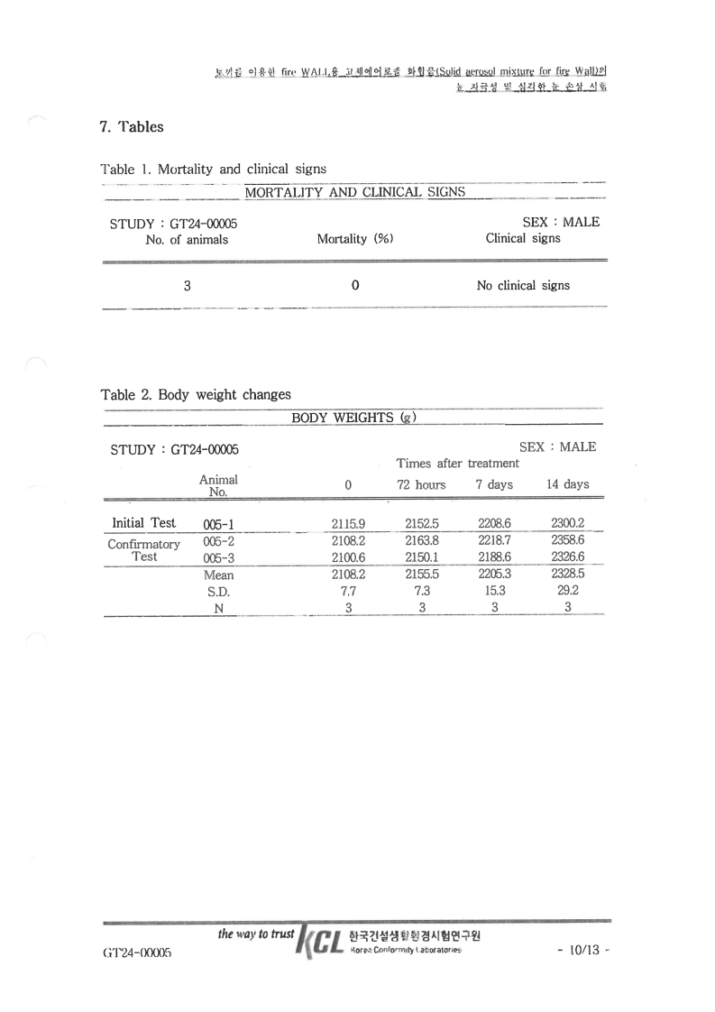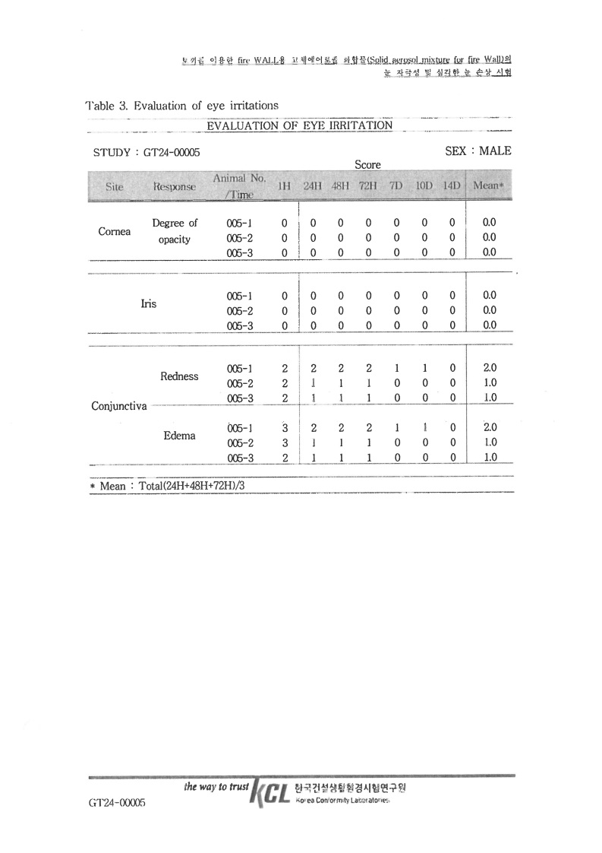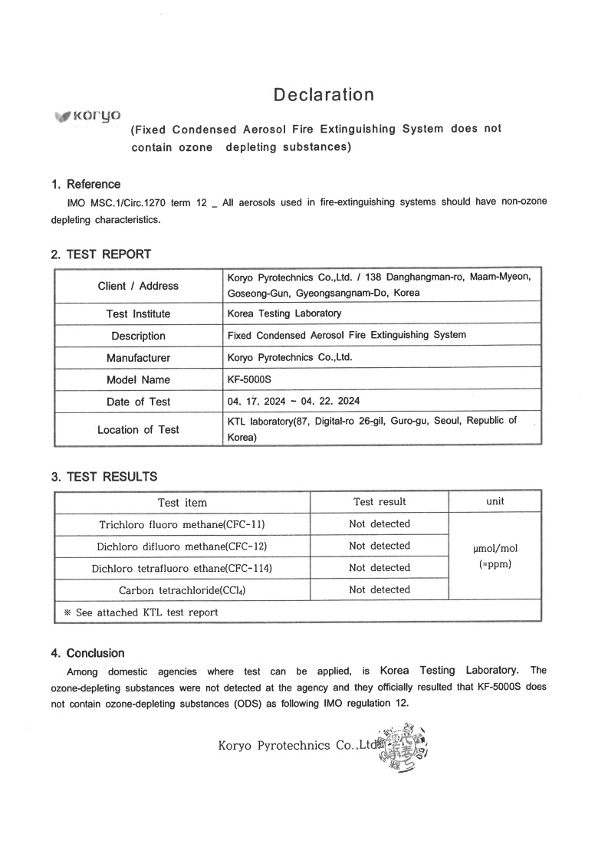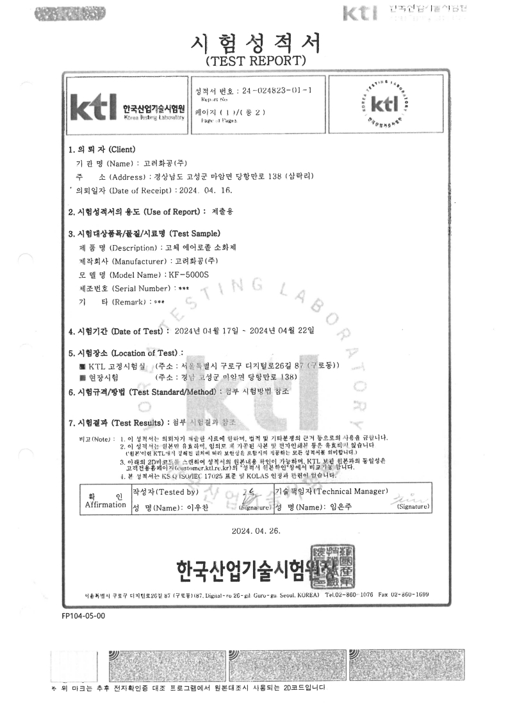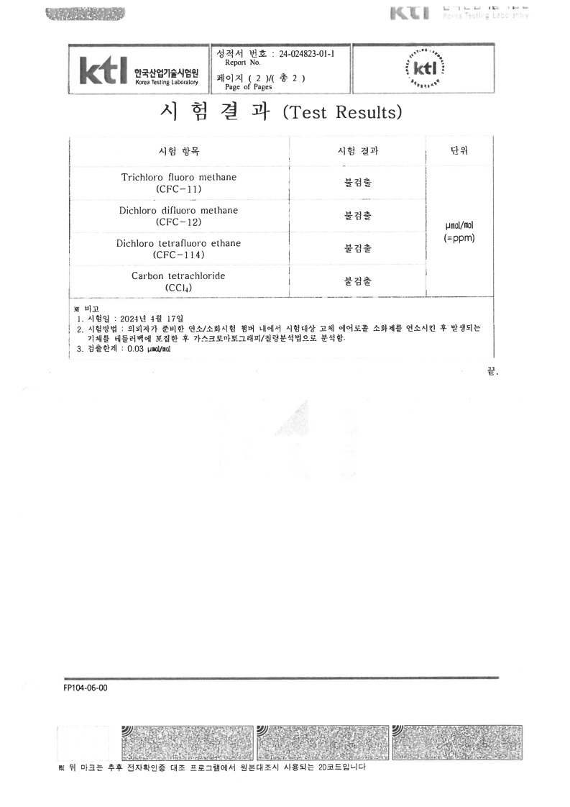

**Appendix-IV**

**Gas sampling resources**

**(Combustibles/Installation-specific materials)**



